SOLAR LIGHTING SYSTEM

Lyric Haylow

Jeb Malek

Josh George

**FINAL REPORT**

REVISION – 3

30 April 2024

Final report

for

Solar Lighting System

Team 60

Approved by:

_____________________________

Project Leader Date

_____________________________

Prof. Pranav Date

_____________________________

T/A Rhett Guthrie Date

Table of Contents

List of Tables VI

List of Figures VII

Concept of Operations

Fiunctional System Requirements 8

Interface Control Document 9

Subsystem Reports

Solar Charge Controller  11

Power Delivery 11

Microcontroller Subsystem 12

Mobile Application 13

System Description andFinal Report 14

Appendix A: Acronyms and Abbreviations 11

Appendix B: Definition of Term 12

SOLAR LIGHTING SYSTEM

Lyric Haylow

Jeb Malek

Josh George

**Concept of Operations**

REVISION – 3

30 April 2024

**Change Record**

|  |  |  |  |  |
| --- | --- | --- | --- | --- |
| **Rev.** | **Date** | **Originator** | **Approvals** | **Description** |
| **1** | 08/29/2023 | Team 60 | JM, JG, LH | Draft Release |
| **2** | 09/28/2023 | Team 60 | JM, JG, LH | Draft Revision |
| **3** | 04/30/2024 | Team 60 | JM, JG, LH | Final Submission |

List of Tables

Table 1.

List of Figures

# Figure 1. Subsystem Diagram

**Figure 2. Solar Lighting System Functional Block Diagram**

**Figure 3. Power Requirements**

**Figure 4.**

**Figure 5.**

**Figure 6.**

**Figure 7.**

**Figure 8.**

**Figure 9.**

# Executive Summary

The purpose of this project is to offer a simple and reproducible solution to address growing environmental concerns by utilizing renewable energy and sensors to reduce power consumption. The problem being addressed with this scope of work is the need for distributed off-grid power solutions to lessen burden on the current grid demand. Our aim is to develop a solar lighting system for two places in a house: the foyer (indoor) and the porch (outdoor). The panel gets energy from the sun and stores it in a battery for the lights. Sensors are used to determine when to turn on lights in both places. Outdoor lights can use motion sensors along with location data to turn on only at night. Indoor lights can use motion sensors to avoid unnecessary triggers by pets. For remote operation, a mobile application is provided for displaying system status and input from the users for their preferences.

# Introduction

This document is an introduction to a Solar Lighting System (SLS), a system which makes use of renewable energy and sensors to provide a light source to several areas of the house with a sustainable source of energy. The outdoor light will turn on when motion activated and only during the night, illuminating people or small animals moving around in a dedicated space. The indoor lighting system will be motion activated as well, operating throughout all hours of the day. The entire system will be environmentally clean, limiting excess damage to our atmosphere from the usage of nonrenewable sources. An app will be implemented with the system, supplying the user with preferential control over the lights. Additionally, implementation of solar energy will provide homeowners with potential tax credits.

## Background

The world relies primarily on nonrenewable sources of energy such as coal, oil, and natural gas to run countless systems. It is no secret that these sources can have harmful effects on our environment. In 2010, coal alone contributed to 35% of the United States’ emissions of carbon dioxide into the atmosphere. In addition to this, burning petroleum releases an abundance of harmful emissions and chemicals into the air and contaminates nearby ecosystems. The need for clean, renewable sources of energy is more apparent than ever, and yet many hesitate to make the change due to concerns about potential declines in efficiency or the difficulty in implementing such a system.

The Solar Lighting System (SLS) intends to provide environmentally clean, economically efficient, and easy-to-use indoor and outdoor lighting systems to potential homeowners. This system aims to replace active systems relying on city or state-wide power grids with a much more localized, environmentally friendly option. Although the positive environmental benefits of solar energy are well known, some consumers may be concerned about the budgetary risks or long-term performance of these panels. Solar panels typically last between 25 to 30 years before degrading in efficiency; in that time, homeowners may expect savings of up to $1,500 a year after switching from their existing power provider. Additionally, the Federal Tax Credit (2022) offers a 26% rebate on the installation of solar panels.

## Overview

The SLS will integrate solar panels and a battery to provide light to a variety of areas in a house. The panels will absorb light from the sun during the day and provide energy to the battery in an efficient manner.

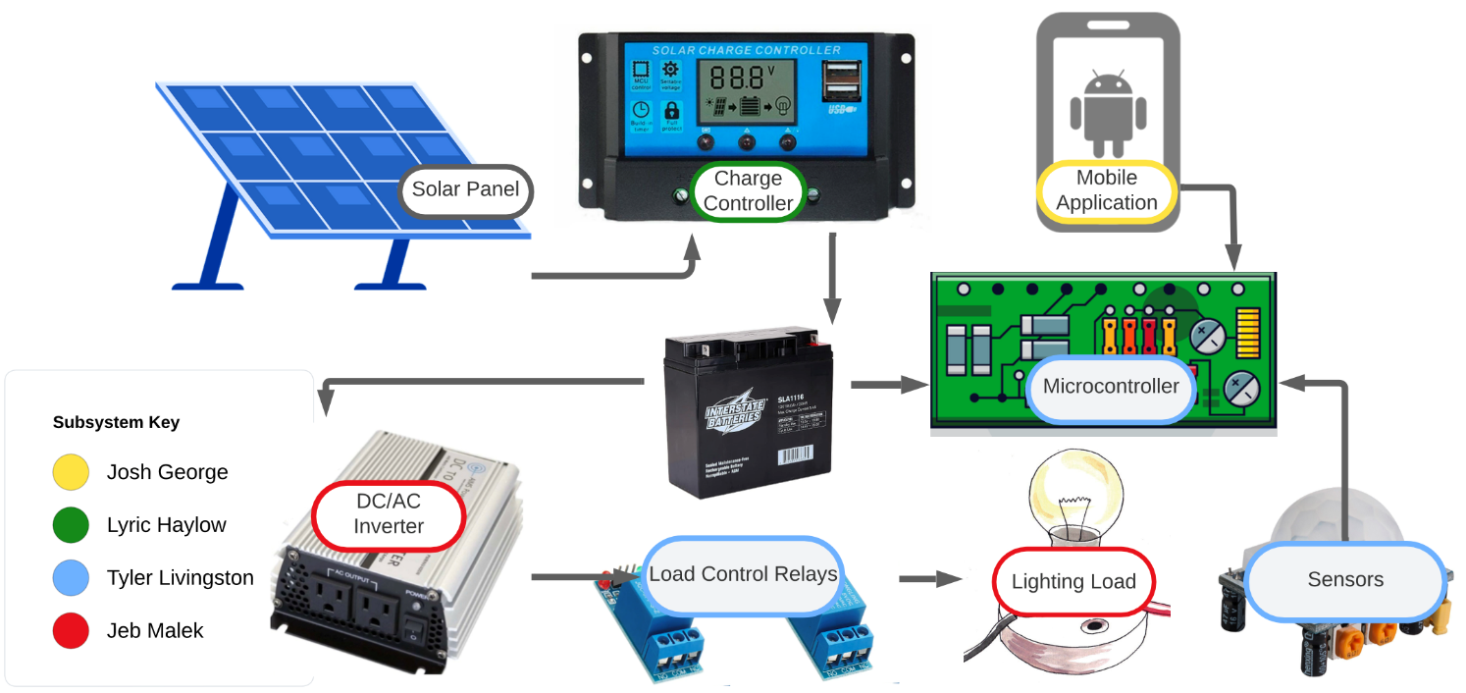

Figure 1. Subsystem Diagram

## Referenced Documents and Standards

"IEEE Recommended Practice for Installation and Maintenance of Lead-Acid Batteries for Photovoltaic (PV) Systems - Redline," in IEEE Std 937-2019 (Revision of IEEE Std 937-2007) - Redline , vol., no., pp.1-45, 28 Feb. 2020.

"IEEE Standard for Interconnection and Interoperability of Distributed Energy Resources with Associated Electric Power Systems Interfaces," in *IEEE Std 1547-2018 (Revision of*

*IEEE Std1547-2003) , pp.1-138, 6 April 2018, doi: 10.1109/IEEESTD.2018.8332112.*

"IEEE Guide for Array and Battery Sizing in Stand-Alone Photovoltaic (PV) Systems,"

in *IEEE Std 1562-2007* , pp.1-32, 12 May 2008, doi: 10.1109/IEEESTD.2008.4518937.

# Operating Concept

## Scope

The Solar Lighting System (SLS) is intended to allow commercial consumers of electricity to easily use renewable energy to power a lighting system in their homes. Two sets of lighting fixtures, along with corresponding sensors for those lights, will be installed in the patio and the foyer of a home. For ease of use, sensors are provided so that the system is powered at opportune times, without the need for manual interaction. They’ll primarily be motion sensors, with programs designed to recognize people rather than animals, or moving objects. The sensors will be connected to an app through Bluetooth for the purpose of manual and remote control of light switches. All systems within the house will be in turn powered by a solar panel that is set to charge the battery as needed when solar power is available. The system is intended primarily for commercial use in houses; however, it could be upscaled to industrial use.

## Operational Description and Constraints

This solar lighting system is intended to be used by the average homeowner in an area with ample sunlight. Solar panels will be installed on a high, unobscured surface outdoors. Motion sensors will be installed indoors and outdoors to activate lights. An app will control light preferences and provide data for battery and lights.

The following constraints are needed for this system:

* Direct sunlight will be needed in the installation spot for the solar panel.
* A direct line of sight will be needed for the motion sensors. Indoor motion sensors will need to be established to avoid accidental triggering by pets.
* A separate device will be necessary for app implementation. This device will need to be near the system to connect.

## System Description

* **Solar Panel:** This subsystem will send power to the battery charge controller, and power the whole system. The solar panel will charge the battery during the day until it reaches a full charge. A singular solar panel will be used, and placed preferably in a location that will get a large amount of sunlight, such as on a roof.
* **Battery Network:** The battery network system is comprised of a battery charge controller and the battery itself. The battery charge controller will ensure that the battery will not get overcharged or fed too quickly, and the battery will power the entire system during operational hours.
* **Microcontroller:** The microcontroller subsystem will interface with each individual component within the system other than the solar panel and battery. It will manage the sensor inputs and mobile app instructions, and in turn control the Load Control switches for the lights.
* **Sensors:** While the system is in automatic mode, it will be triggered by motion sensors, both in the foyer and the patio. The motion sensors will be programmed to recognize only movements made by people, rather than pets or a random moving object. Both the foyer and the patio will be using the same sensors and programmed to behave the same.
* **Lights:** The lights used will differ based on the location they are in and for what purpose they are being used. In the foyer, 3 LED lights will be set up to be activated by the motion sensors in that area and have a manual switch in the foyer. An outdoor light will be set up in the patio, though this one will only be activated by a manual switch and by the motion sensors for a limited time. An additional smaller LED light will be set up above the door of the patio, to be kept on whenever the app receives a signal that it has become appropriately dark.
* **Mobile Application:** The mobile app will be designed on Android Studio and will be able to connect to the SLS using Bluetooth. Data regarding panel irradiation and battery levels will be provided to the user through the app. The user will also be able to set their lighting preferences and modes with the app. The app will track sunlight and weather data in the user’s location to determine when the lights and certain sensors should be active.

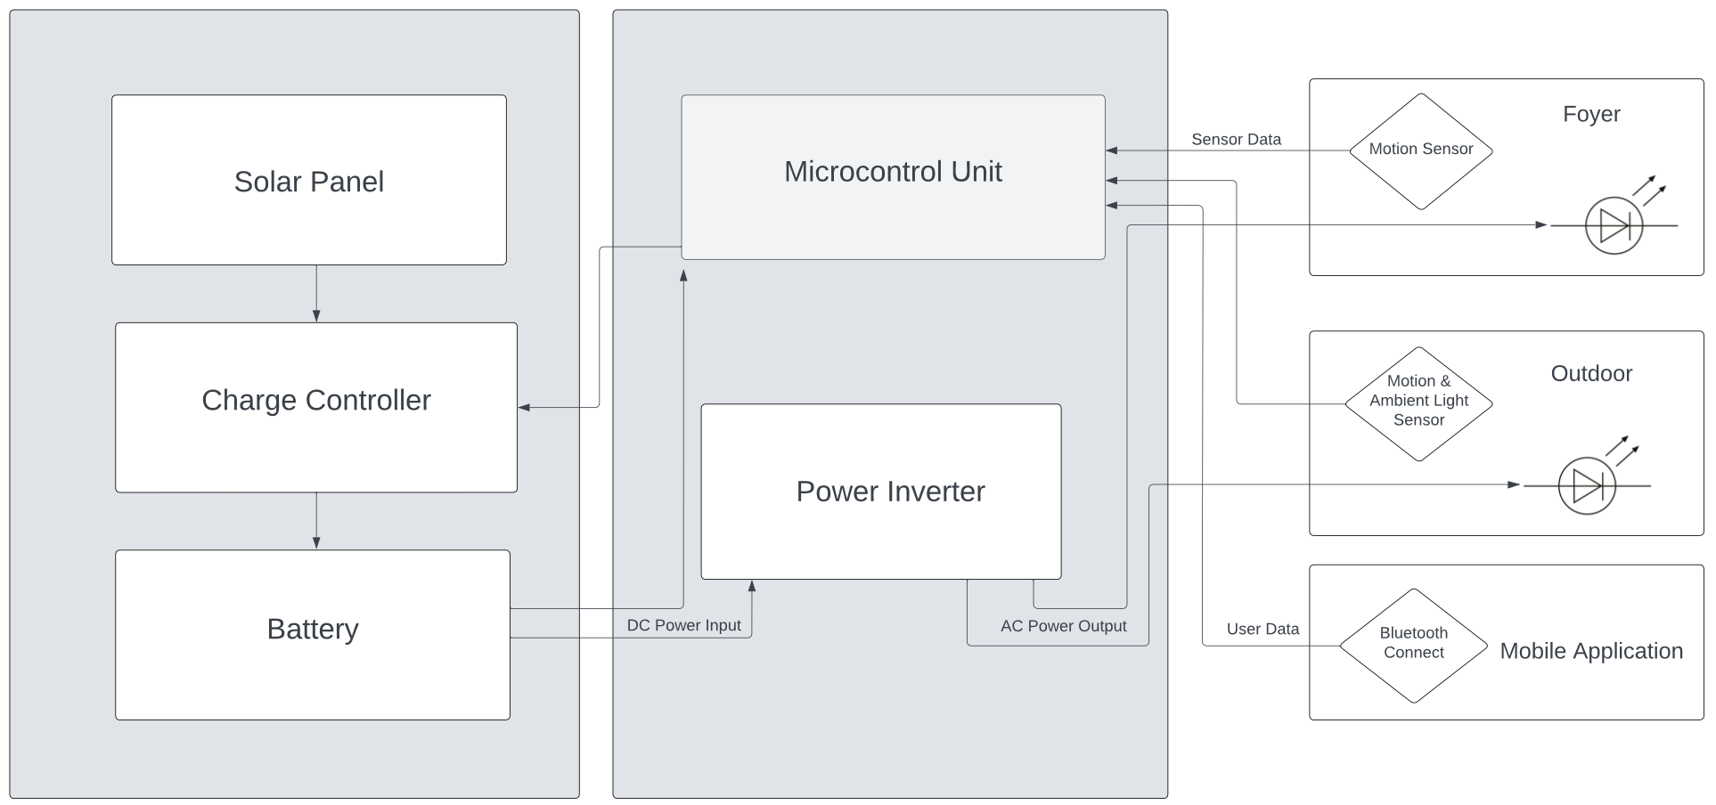

**Figure 2. Solar Lighting System Functional Block Diagram**

## Modes of Operations

The Solar Lighting System will have two modes of operation that it functions from: ‘Automatic’ and ‘Manual’. The mode of operation can be controlled by a manual switch attached to the MCU, as well as by the app.

* **Automatic:** The SLS will function without need for constant interaction and will work until fault. Both the inside foyer lights as well as the outside patio lights will be triggered by any motion picked up from their respective motion sensors.
* **Manual:** The SLS can also be operated manually, triggering lights and sensors with a switch. The inside and outside lights can be operated either with a physical switch or a switch within the app.

## Users

This Solar Lighting System is intended for the everyday homeowner wishing to reduce their impact on the environment regarding carbon footprints, as well as diminish the cost of their utility bills. It will be designed such that the average person should have no issues with installation or use.

## Support

Support for the Solar Lighting System will be provided through a user manual and online support through the developed app. The user manuals will come with easy-to-understand installation instructions, with additional documentation for each subsystem to help with troubleshooting. Online support through the app will come with frequently asked questions and their answers, and another copy of the user manual in PDF format.

# Scenarios

## Porch

Whenever the light sensor detects that it is dark, a small light will illuminate the entrance from the porch to the house. If some unidentified object triggers the motion sensor, a light will turn on illuminating the porch. The user will be able to customize when these lights turn on using the app.

## Foyer

Whenever the user enters or exits the foyer, the motion sensor will turn on or turn off the light. The app can also be used to control this light according to the users' preferences.

## Rooftop

Solar panel should be mounted on the southern facing side of a user’s installation site. This will ensure the most efficient operation of the cell for the desired power rating.

# Analysis

## Summary of Proposed Improvements

The Solar Lighting System promises a variety of benefits, including:

* The system will be solar powered, providing environmentally clean and self-sustaining energy.
* The outdoor lights will only be active at night, limiting resource consumption during the day.
* Motion sensors will be implemented for indoor and outdoor lighting systems, limiting resource consumption when there is no one around. The outdoor motion sensor will be implemented with an outdoor light, illuminating moving objects when it is dark.
* Homeowners will save money over time from smaller energy bills and tax credits.
* The solar panels will last 25 to 30 years before degrading in efficiency.
* The app will provide an easy-to-use interface for consumers to interact with the system. The interface will display light and battery data and will also allow users to set preferences and modes.

## Disadvantages and Limitations

The Solar Lighting System has a few limitations, including:

* The sunlight received by the solar panel can vary based on location and weather patterns. This causes the energy source to be intermittent.
* The initial cost of the system will be substantial.
* Once the old panels degrade, new ones will have to be installed.
* The app will require a device with Bluetooth capabilities.

## Alternatives

Some alternatives to the Solar Lighting System are:

* Staying with the existing system provided by a power grid. This requires no extra installation costs or difficulties but will not save money over time and will not necessarily be clean.
* Switching to another form of renewable energy to power the lights. Solar power is currently the most commercially available form of renewable energy. Any other installations will be difficult to engineer and incredibly expensive.

## Impact

Three key impacts of this system are reduced greenhouse gas emissions, renewable energy sourcing, and economic relief. There are few environmental or ethical concerns about solar panels, only concerns regarding their efficiency and cost. The global impact of the SLS increases as the number of consumers increases.

SOLAR LIGHTING SYSTEM

Lyric Haylow

Jeb Malek

Josh George

**Functional System Requirements**

REVISION – 3

3 December 2023

Functional System Requirements

for

Solar Lighting System

Prepared by:

_____________________________

Team 60 Date

Approved by:

_____________________________

John Lusher, P.E. Date

_____________________________

T/A Zhewen Date

**Change Record**

|  |  |  |  |  |
| --- | --- | --- | --- | --- |
| **Rev.** | **Date** | **Originator** | **Approvals** | **Description** |
| **-** | 09/28/2023 | Team 60 |  | Draft Release |

Table of Contents

Table of Contents IV

List of Tables V

List of Figures VI

Figure 1. Solar Lighting System Conceptual Image VI

1. Introduction 1

1.1. Purpose and Scope 1

1.2. Responsibility and Change Authority 2

2. Applicable and Reference Documents 2

2.1. Applicable Documents 2

2.2. Reference Documents 3

2.3. Order of Precedence 3

3. Requirements 3

3.1. System Definition 3

3.2. Characteristics 4

3.2.1. Functional / Performance Requirements 4

3.2.2. Physical Characteristics 5

3.2.3. Electrical Characteristics 6

3.2.4. Environmental Requirements 8

3.2.5. Failure Propagation 9

4. Support Requirements 10

Appendix A: Acronyms and Abbreviations 11

Appendix B: Definition of Terms 12

List of Tables

**Table 1. System Responsibility..........................................................................................2**

List of Figures

# Figure 1. Solar Lighting System Conceptual Image

**Figure 2. Block Diagram of Solar Lighting System**

# Introduction

## Purpose and Scope

Providing power for the everyday activities that an average household consumer does can cost a significant amount of money. To lower electricity costs, as well as help make our power sources cleaner, we offer the Solar Lighting System (SLS). This project is intended to use solar energy to power a lighting system that can be used throughout both night and day. The solar panel will actively charge a 12V 18Ah battery, and through a microprocessor controlling multiple sensors, lights appropriate for the time of day will turn on. We’ll be lighting both the inside foyer and the outside patio. Motion sensors will be in both locations to turn on the lights as needed based on detected movement, and appropriate software will be applied to ensure only people are registered as valid moving objects. An additional light will be installed in the patio area, to be controlled by the motion sensors, and a standalone light will be on constantly at night. Our system will limit the need for directly turning on lights that are used in high traffic areas and help with the utility bill of the consumer.

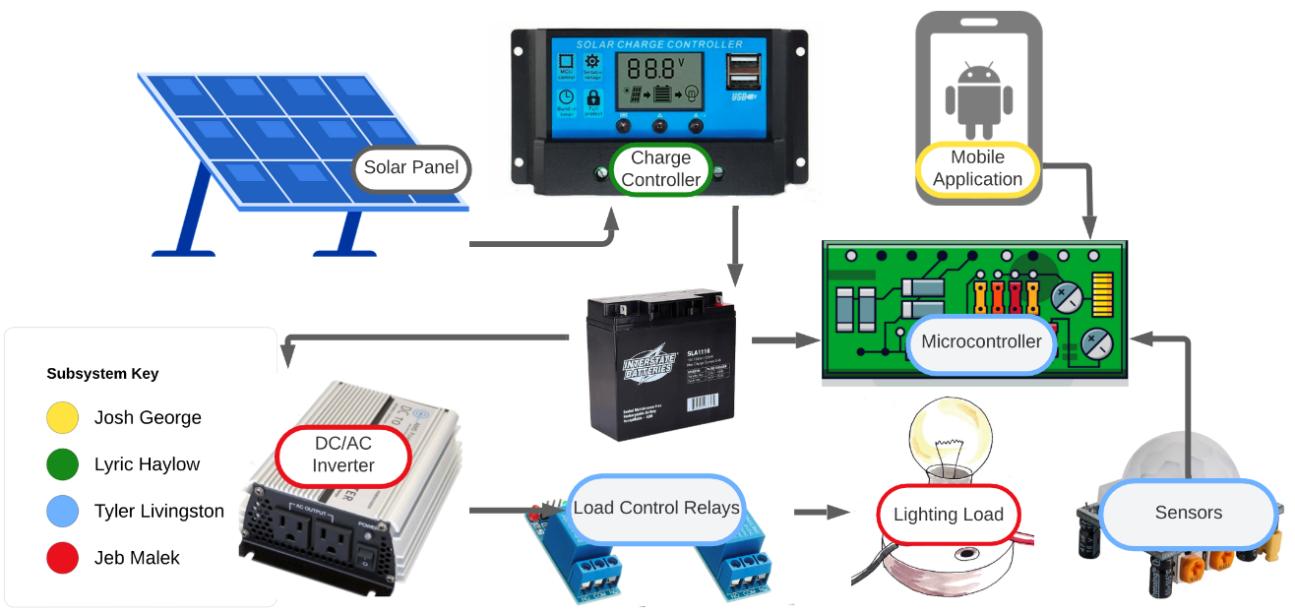

Figure 1. Solar Lighting System Conceptual Image

The following definitions differentiate between requirements and other statements.

Shall: This is the only verb used for the binding requirements.

Should/May: These verbs are used for stating non-mandatory goals.

Will: This verb is used for stating facts or declaration of purpose.

## Responsibility and Change Authority

Josh George, our team leader, will be responsible for the confirmation of requirements being met. The requirements will only be changed with approval from the team leader and Wonhyeok Jang.

|  |  |
| --- | --- |
| **Subsystem** | **Responsibility** |
| Battery Charger | Lyric Haylow |
| Power Inverter | Jeb Malek |
| Microcontroller | Josh George / Jeb Malek |
| Mobile App | Josh George |

Table 1. System Responsibility

# Applicable and Reference Documents

## Applicable Documents

The following documents, of the exact issue and revision shown, form a part of this specification to the extent specified herein:

|  |  |  |
| --- | --- | --- |
| **Document Number** | **Revision/Release Date** | **Document Title** |
| ANSI C119.6-2011 | May 5, 2011 | American National Standard for Electric Connectors |
| 46 CFR Part 111 Subpart 111.15 | June 4, 1996 | Storage Batteries and Battery Chargers: Construction and Installation |
| IEEE 937 | February 28, 2020 | Recommended Practice for Installation and Maintenance of Lead-Acid Batteries for  Photovoltaic (PV) Systems |
| IEEE 1547 | April 6, 2018 | Standard for Interconnection and Interoperability of Distributed Energy Resources with  Associated Electric Power |
| IEEE 1562 | May 12, 2008 | Guide for Array and Battery Sizing in Stand-Alone |

Table 2. Applicable Documents

## Reference Documents

The following documents are reference documents utilized in the development of this specification. These documents do not form a part of this specification and are not controlled by their reference herein.

|  |  |  |
| --- | --- | --- |
| **Document Number** | **Revision/Release Date** | **Document Title** |
| AN10216-01 | March 24, 2003 | I2C Manual |

Table 3. Reference Documents

## Order of Precedence

In the event of a conflict between the text of this specification and an applicable document cited herein, the text of this specification takes precedence without any exceptions.

All specifications, standards, exhibits, drawings or other documents that are invoked as “applicable” in this specification are incorporated as cited. All documents that are referred to within an applicable report are considered to be for guidance and information only, except ICDs that have their relevant documents considered to be incorporated as cited.

# Requirements

This section defines the minimum requirements that the development item(s) must meet. The requirements and constraints that apply to performance, design, interoperability, reliability, etc., of the system, are covered.

## System Definition

The Solar Lighting System is an ecologically clean and fiscally efficient option for lighting various locations of a home environment. It provides electricity to a set of lights indoors and outdoors powered solely by solar energy. The SLS has four primary subsystems: Battery Charger, Power Inverter, Microcontroller, and Mobile Application.

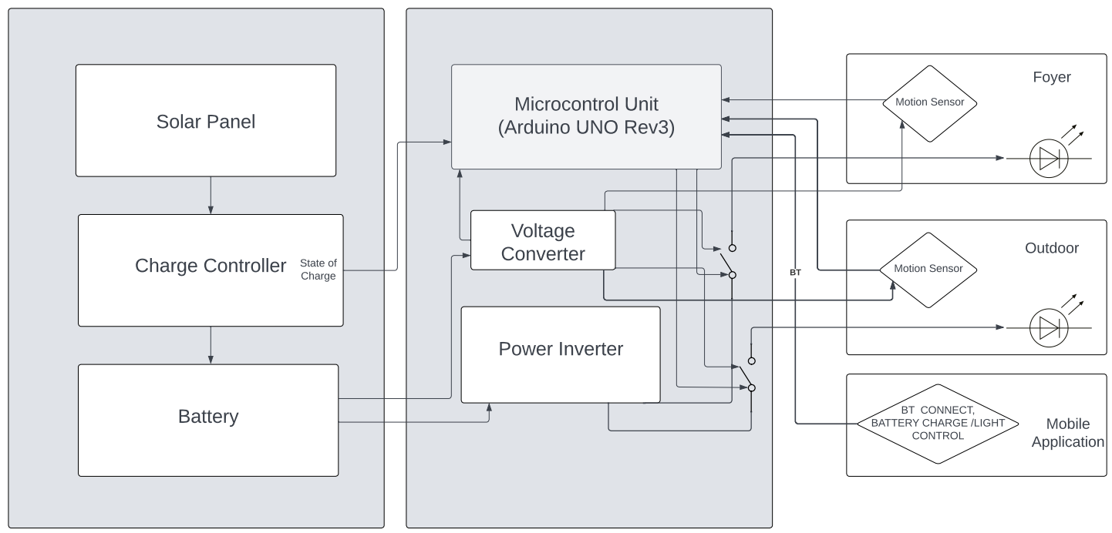

Figure 2. Block Diagram of Solar Lighting System

Described in the diagram above are the functional interconnections of the SLS. The figures outlined on the left represent the battery charging subsystem with the battery storage and charge controller grouped with the photovoltaic panel.

## Characteristics

### Functional / Performance Requirements

#### Solar Panel Efficiency

The minimum solar power efficiency, the effectiveness at which the panel converts sunlight to electricity, shall be greater than 15%.

Rationale: Most commercial panels have efficiencies of at least 15%. Decent solar panel efficiency is required in order to obtain the maximum possible sunlight to electricity conversion. The battery will be charged more with higher efficiency.

#### Power Inverter Efficiency

The minimum Power Inverter efficiency shall be 75%.

Rationale: It is important to have a relatively high efficiency to avoid wasting energy as the Solar Lighting System is powered finitely via battery.

#### Battery Operating Time

The Solar Lighting System shall be able to function for 12-hour period from full battery life.

Rationale: Assuming a night cycle of 12 hours, the Solar Lighting System will at a minimum need to function this one-night cycle on one battery charge.

#### Indoor Sensor Miss Rate

The Solar Lighting System’s indoor sensor shall not exceed a threshold miss rate of 5%.

Rationale: This tolerance accounts for the edge cases such as possible misses from an object passing through the edges of the effective range. It also accounts for cases in which users may be carrying objects that block their heat signature from the sensor.

#### Outdoor Sensor Miss Rate

The Solar Lighting System’s outdoor sensor shall not exceed a threshold miss rate of 10%.

Rationale: This increased threshold percentage is to consider the various environmental factors that may affect the sensor’s detection. Also, it also considers the edge cases mentioned in Indoor Sensor Miss Rate.

#### Response Time

The Solar Lighting System shall have a maximum response time, from sensor detection to light activation, of 2 seconds.

Rationale: This limit of a maximum response time is needed to ensure the user’s quality of life.

### Physical Characteristics

#### Indoor Sensor Placement

The Solar Lighting System’s indoor sensor requires installation mounted between 4ft and at most 15ft above the desired detection area on a 90-degree vertical surface, facing the foyer, and out of reach of indoor pets. The user may physically block certain parts of the sensor to modify the FOV and thus modify the height needed.

Rationale: The sensor will capture little to no movement if installed incorrectly. To ensure proper system functionality, the sensors must be mounted as specified. Additionally, the sensor should be mounted at four or more feet off the ground so that pets are outside the sensor’s detection area.

#### Outdoor Sensor Placement

The Solar Lighting System’s outdoor sensor requires installation mounted at least 6ft above desired detection area on a 90-degree surface, facing the desired outdoor area.

Rationale: The sensor will capture little to no movement if installed incorrectly. To ensure proper system functionality, the sensors must be mounted as specified.

#### Volume Envelope

The volume envelope of a single light without the solar panel, battery, or sensors shall not exceed 8 cubic inches. The volume envelope of the motion sensors shall not individually exceed 6 cubic inches. The volume envelope of the main control unit, with battery included, shall not exceed one cubic foot.

Rationale: The light and sensor nodes should be small enough to easily mount on house walls, while also being large enough to not be inconspicuous. The main unit will consist of a solar charge controller, a battery, and a microcontroller to facilitate all activities.

#### Mounting Location

The Battery Unit falls under the small size battery installations and shall not be located in poorly ventilated spaces, such as closets, or in living spaces, such as staterooms. The lining for lead-acid batteries storage lockers, the lining shall be at least 1.6 mm (1⁄16 inch) thick lead or other material that is corrosion-resistant to the electrolyte of the battery. The main unit including microcontroller and power inverter shall be best located indoors away from contamination.

Rationale: This mounting information ensures the safe keeping of the battery and components of the Solar Lighting System.

### Electrical Characteristics

#### **Inputs**

1. The presence or absence of any combination of the input signals in accordance with ICD specifications applied in any sequence shall not damage the Search and Rescue System, reduce its life expectancy, or cause any malfunction, either when the unit is powered or when it is not.
2. No sequence of command shall damage the Solar Lighting System, reduce its life expectancy, or cause any malfunction.

Rationale: By design, should limit the chance of damage or malfunction by user/technician error.

##### Power Consumption

1. The maximum peak power of the system shall not exceed 200 watts.

Rationale: This is a requirement specified due to constraints of their system in which the Battery Charging System is integrating.

##### Input Voltage Level

The input voltage level for the Battery Charging System shall be +22 VDC to +29 VDC from the PV Cell.

Rationale: Inverters, Converters, Controllers, and Interconnection Systems for Use with Distributed Energy Resources UL 1741

##### Input Noise and Ripple

The input noise and ripple for the Power Inverter shall operate while in the presence of a 1.5 Volt RMS ripple superimposed on the steady-state voltage over the frequency range of 0 Hz to 60 Hz AC.

Rationale: Inverters, Converters, Controllers and Interconnection Systems for Use with Distributed Energy Resources UL 1741.

#### **Outputs**

##### Data Output

The Mobile App shall include an interface displaying general system data.

Rationale: Using the mobile app, the user should have convenient and easy access to data such as power consumption, battery life, etc.

##### Sensor Output

The outputs from the motion sensors and ambient light sensors shall be designed to connect to the microcontroller via wire.

Rationale: Wired connection is a standard and relatively easy way to transmit data from sensors to microcontroller.

#### **Connectors**

The Solar Lighting System shall be designed following the standard: ANSI C119.6-2011 National Standard for Electrical Connectors

Rationale: Conform to connector standards.

#### **Wiring**

The Solar Lighting System shall conform to the guidelines in the National Electric Code regarding electrical wiring.

Rationale: Conform to wiring standards in the NEC.

### Environmental Requirements

The Solar Lighting System shall be designed to withstand and operate in the environments and laboratory tests specified in the following sections.

#### **Pressure (Altitude)**

The Solar Lighting System shall be designed to operate in altitudes from 0ft (sea level) to 5000ft.

Rationale: The Solar Lighting System is being designed and developed with the average city altitude of 2000ft in consideration.

#### **Thermal**

The Solar Lighting System shall be designed to operate from -4°F to 122°F. A wide variety of temperatures is necessary considering that the solar panel, as well as the sensors, are located outside and subject to climate changes.

Rationale: This is based on temperature specifications of the battery, sensor, and microcontroller.

#### **External Contamination**

The Solar Lighting System shall be designed with normal contamination such as dust, pollen, etc. The effectiveness of the system outside of normal contamination will not be guaranteed.

Rationale: The Solar Lighting System is being designed with the average homeowner's use-case in mind; it should withstand household contamination.

#### **Rain**

The Solar Lighting System’s solar panel connections shall be designed to withstand rain. The main unit including the battery, inverter, and microcontroller will need to be stored indoors or in an enclosure protected from the rain.

Rationale: The microcontroller and battery as stated would be best kept indoors away from the elements. The solar panel and its connectors will need to withstand rain as it is outdoors.

#### **Humidity**

The Solar Lighting System shall be designed to operate in a humidity range of 0% to 95%.

Rationale: This humidity range includes the expected humidities of most cities or where households would reside.

### Failure Propagation

#### **Failure Detection**

The microcontroller should be able to detect a critical failure in the Solar Lighting. The microcontroller may identify the user using the mobile app.

Rationale: The Solar Lighting System is being designed with the average homeowner's use-case in mind; it should withstand household failures.

# Support Requirements

The user will require a mobile device with Bluetooth connectivity to utilize the Solar Lighting System to its full potential. The user must install the Solar Lighting System including its components.

# Appendix A: Acronyms and Abbreviations

EMC Electromagnetic Compatibility

EMI Electromagnetic Interference

EO/IR Electro-optical Infrared

FOR Field of Regard

FOV Field of View

GPS Global Positioning System

GUI Graphical User Interface

Hz Hertz

ICD Interface Control Document

kHz Kilohertz (1,000 Hz)

LED Light-emitting Diode

mA Milliamp

MHz Megahertz (1,000,000 Hz)

MPP Maximum Power Point

MPPT Maximum Power Point Tracking

MTBF Mean Time Between Failure

MTTR Mean Time To Repair

W Watt

mW Milliwatt

PCB Printed Circuit Board

RMS Root Mean Square

SLS Solar Lighting System

TBD To Be Determined

USB Universal Serial Bus

# Appendix B: Definition of Terms

Solar Lighting System (SLS) Complete system being designed.

Solar Lighting System

Josh George

Lyric Haylow

Jeb Malek

**Interface Control Document**

REVISION – Draft

28 September 2023

Interface Control Document

for

Solar Lighting System

Prepared by:

_____________________________

Team 60 Date

Approved by:

_____________________________

Team 60 Date

_____________________________

John Lusher II, P.E. Date

_____________________________

T/A Zhewen Date

**Change Record**

|  |  |  |  |  |
| --- | --- | --- | --- | --- |
| **Rev.** | **Date** | **Originator** | **Approvals** | **Description** |
| **-** | 9/28/2023 | Team 60 |  | Draft Release |

Table of Contents

Table of Contents III

List of Tables IV

List of Figures V

1. Overview 1

2. References and Definitions 2

2.1. References 2

2.2. Definitions 2

3. Physical Interface 3

3.1. Weight 3

3.1.1. Solar Panel and Charge Controller 3

3.1.2. Microcontroller Unit and Sensors 3

3.1.3. Power Inverter **Error! Bookmark not defined.**

3.2. Dimensions **Error! Bookmark not defined.**

3.2.1. Dimensions of Solar Panel Charging 4

3.2.2. Dimensions of Power Inverter 4

3.2.3. Dimensions of Microcontroller and Sensors 4

3.3. Mounting Locations 4

3.3.1. Mounting Location of Solar Panel 4

3.3.2. Mounting Indoor Sensor 4

3.3.3. Mounting Outdoor Sensor 5

4. Thermal Interface 5

4.1. Inverter Cooling 5

4.2. Battery Cooling 5

5. Electrical Interface 6

5.1. Primary Input Power 6

5.1.1. Lights 6

5.1.2. Microcontroller Unit and Sensors 6

5.2. Signal Interfaces 6

5.2.1. Sensors 6

5.3. Voltage and Current Levels 7

5.3.1. Maximum Values 7

5.4. User Control Interface 7

6. Communications / Device Interface Protocols 8

6.1. Bluetooth 8

6.2. Device Peripheral Interface 8

List of Tables

**Table 1. Solar Panel Charging Weight**

**Table 5 Microcontroller and Sensor Weights**

**Table 3. Power Inverter Weight**

**Table 4. Solar Panel Charging Dimensions**

**Table 5. Power Inverter Dimensions**

**Table 6. Main Control Dimensions**

List of Figures

# Figure 1. System Description Diagram

Error! Reference source not found.**.** Error! Reference source not found.

# Overview

This document provides a brief overview of how the solar panel cell, solar charge controller, lead-acid battery, power inverter, control unit, and lighting load will interconnect in the Solar Lighting System functionality. First, an explanation of how the panel will link up with the charge controller will be given, along with how that controller will charge the battery. Then, the charge inputs to the microcontroller and the power inverter will be described. The relay from the inverter to the lights will be explained. Finally, the connection of the mobile application to the microcontroller unit will be detailed as well.

# References and Definitions

## References

Refer to section 2.2 of the Functional System Requirements document.

## Definitions

A Ampere

MHz Megahertz (1,000,000 Hz)

m Meter

mm Millimeter

N/A Not Applicable

TBD To Be Determined

U/N Unknown

uA Micro Ampere

W Watt

# Physical Interface

## Weight

### 

### Solar Panel and Charge Controller

|  |  |  |  |
| --- | --- | --- | --- |
| **Component** | **Weight** | **Number of Items** | **Total Weight** |
| Sunforce Solar Panel | 16 lb | 1 | 16 lb |
| Battery | 11 lb | 1 | 11 lb |
| MPPT | TBD | 1 | TBD |
| Charge Controller | TBD | 1 | TBD |

Table 4 Solar Panel Charging Weight

|  |  |  |  |
| --- | --- | --- | --- |
| **Component** | **Weight** | **Number of Items** | **Total Weight** |
| PCB Board |  | 1 |  |
| Fan |  | 1 |  |
| Power Transformer |  | 1 |  |
| Inverter Casing |  | 1 |  |

Table 3 Power Delivery Weight

### Microcontroller Unit and Sensors

|  |  |  |  |
| --- | --- | --- | --- |
| **Component** | **Weight** | **Number of Items** | **Total Weight** |
| ESP32-WROVER-E-N12R8 | U/N | 1 | U/N |
| EKMB1393111K | U/N | 1 | U/N |
| EKMB4303111K | U/N | 1 | U/N |
| APDS-9306-065 | U/N | 1 | U/N |

Table 5 Microcontroller and Sensor Weights

Table 4. Solar Panel Charging Dimensions

### Dimensions of Solar Panel Charging

|  |  |  |  |
| --- | --- | --- | --- |
| **Component** | **Length** | **Width** | **Height** |
| Solar Panel | 43in | 17in | 4.5in |
| Charge Controller | TBD | TBD | TBD |
| Battery | 7.13in | 3in | 6.6in |
| MPPT | TBD | TBD | TBD |

### Dimensions of Power Inverter

|  |  |  |  |
| --- | --- | --- | --- |
| **Component** | **Length** | **Width** | **Height** |
| PCB | 6 | 5 |  |
| Fan |  |  |  |
| Power | 119 | 119 | 58 |
| Inverter |  |  |  |

Table 5. Power Delivery Dimensions [mm]

### Dimensions of Microcontroller and Sensors

|  |  |  |  |
| --- | --- | --- | --- |
| **Component** | **Length (mm)** | **Width (mm)** | **Height (mm)** |
| ESP32-WROVER-E-N12R8 | 31.4 | 18 | 3.3 mm |
| EKMB1393111K | 14.9 | 14.9 | 21.8 |
| EKMB4303111K | 22 | 22 | 24.8 |
| APDS-9036-065 | 2 | 2 | 0.34 |

Table 6. Microcontroller and Sensor Dimensions

## Mounting Locations

Mounting installations include the solar panel, an outdoor motion detector, and an indoor motion detector. Additional items include a battery, a charge control circuit, and a power inverter circuit.

### Mounting Location of Solar Panel

Mounting the solar panel in a region with low year-round or day-to-day sunlight will yield poor charging capabilities and result in below optimal home lighting. The solar panel must be mounted outdoors on a part of the house high in elevation, preferably on a roof or terrace. The panel must not be obstructed from direct sunlight and securely fastened in an area that is not likely to be overcast by shade. The panel should not be placed too far from the charge controller and battery setup, as increasing the distance between the two will consume more resources.

### Mounting Indoor Sensor

The indoor motion sensor should be wall mounted in the foyer at least 5 feet from the ground to avoid accidental triggers by household pets. The sensor must be securely fastened to a 90-degree vertical wall and should be mounted near the door in order to activate upon entering or exiting the foyer.

### Mounting Outdoor Sensor

The outdoor motion sensor should be mounted in the desired outdoor area, such as a side yard or a backyard. The sensor must be securely fastened to a 90-degree vertical wall and mounted at the desired level to activate outdoor lights.

# Thermal Interface

## Inverter Cooling

The Power Inverter will need the use of a DC operated fan for correct ventilation of heat dissipated from switching circuitry.

## Battery Cooling

Sealed Lead Acid batteries come with instructions to keep cells in ambient room temperature with adequate ventilation, which will be validated with waterproof storage design.

# Electrical Interface

* 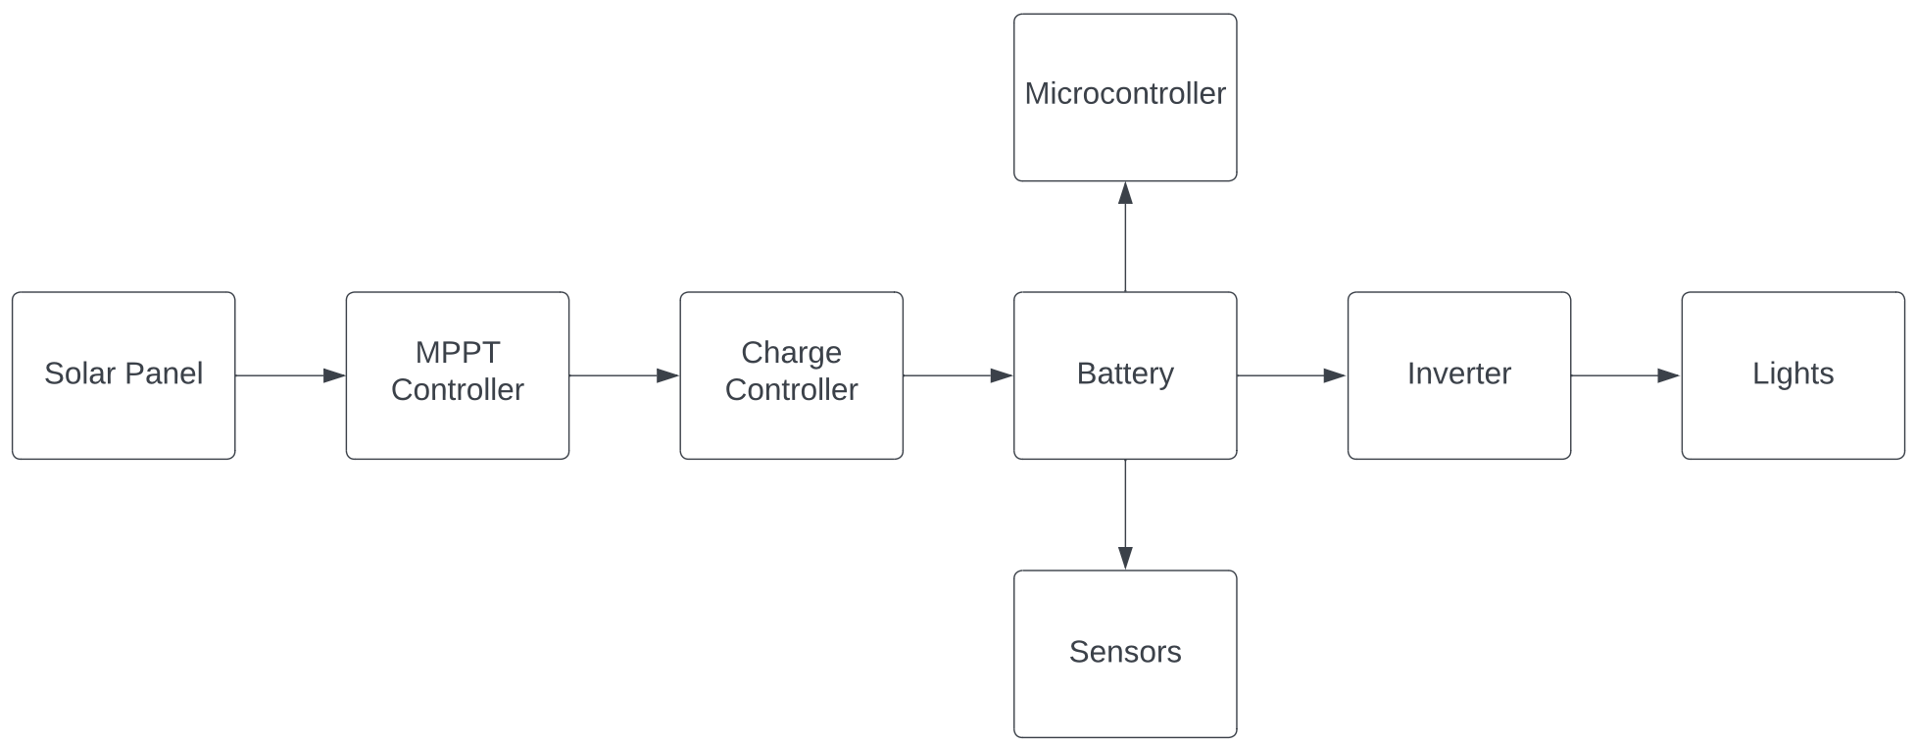

Figure 2. Electrical Interface Diagram

## Primary Input Power

### Lights

The lights will primarily be powered by a 12V 18Ah battery that will be relayed to the lights through a power inverter. At full battery capacity, the lights will be able to run for two full days.

### Microcontroller Unit and Sensors

The battery will provide power to the microcontroller unit and to the sensors. The input voltages of all of these are 3.3V.

## Signal Interfaces

### Sensors

Below are the following sensors that will be used including the type of sensor and the interface protocol of the output.

|  |  |  |  |
| --- | --- | --- | --- |
| **Sensors** | **Sensor Type** | **Interface Protocol** | **Range [m]** |
| EKMB1393111K | PIR (Motion) | Digital | 2.2 |
| EKMB4303111K | PIR (Motion) | Digital | 17 |
| APDS-9306-065 | Ambient Light | I2C | N/A |

*Table 6. Sensor Signal Sensitivities*

## Voltage and Current Levels

### Maximum Values

|  |  |  |  |
| --- | --- | --- | --- |
| **Component** | **Voltage [V]** | **Current [A]** | **Power [W]** |
| Power Inverter | 12 V | 20 | 200 |
| Microcontroller | 3.6 V | 240 mA | 0.250 |
| Sensors | 4 V | 85 uA | - |
| Lights | 120 V AC | 2 | 80 |

*Table 7. Stand-By Voltage and Current*

The values listed in the table above are placed as referenced for nominal power consumption. Manufacturer data sheets provide interconnection characteristics for safe use of the intended circuit. Power consumption from sensors and microcontroller are negligible compared to rated support from the Power Inverter and Battery Capacity.

### Converter Values

**Transformer Part: 0200MD-1-003**

|  |  |  |  |  |
| --- | --- | --- | --- | --- |
| **Component** | **Power [VA]** | **Current [A]** | **No Load [V]** | **Lead Wire[AWG]** |
| Power Transformer | 12 V | 20 | 2x129.1 | AWG #20 |
|  |  |  |  |  |
|  |  |  |  |  |
|  |  |  |  |  |

*Table 7. Transformer Values*

## User Control Interface

The user control interface will be the mobile application that connects to the microcontroller via Bluetooth. The user’s input and preference will be used to adjust modes of lighting motion activations, and settings.

# Communications / Device Interface Protocols

## Bluetooth

The microcontroller utilizes an HC-05 Bluetooth module in order to connect to the app. These protocols will be utilized to connect and transmit data with the mobile application.

## Device Peripheral Interface

The PIR motion sensors will interface digitally directly with the microcontroller. The motion sensor will interface with the microcontroller.

SOLAR LIGHT SYSTEM

Lyric Haylow

Jeb Malek

Josh George

**Subsystem Reports**

REVISION – Final

3 December 2023

**Change Record**

|  |  |  |  |  |
| --- | --- | --- | --- | --- |
| **Rev.** | **Date** | **Originator** | **Approvals** | **Description** |
| **1** | 12/3/2023 | Team 60 |  | Original Release |

Table of Contents

List of Tables VI

List of Figures VII

Figure 1. Subsystem Diagram VII

1. Executive Summary 8

2. Introduction 9

2.1. Background 9

2.2. Overview 10

2.3. Referenced Documents and Standards 10

3. Operating Concept 11

3.1. Scope 11

3.2. Operational Description and Constraints 11

3.3. System Description 11

3.4. Modes of Operations 12

3.5. Users 13

3.6. Support 13

4. Scenarios 14

4.1. Porch 14

4.2. Foyer 14

4.3. Rooftop 14

5. Analysis 15

5.1. Summary of Proposed Improvements 15

5.2. Disadvantages and Limitations 15

5.3. Alternatives 15

5.4. Impact 15

Table of Contents IV

List of Tables V

1. Introduction 1

1.1. Purpose and Scope 1

1.2. Responsibility and Change Authority 2

2. Applicable and Reference Documents 2

2.1. Applicable Documents 2

2.2. Reference Documents 3

2.3. Order of Precedence 3

3. Requirements 3

3.1. System Definition 3

3.2. Characteristics 4

3.2.1. Functional / Performance Requirements 4

3.2.2. Physical Characteristics 5

3.2.3. Electrical Characteristics 6

3.2.4. Environmental Requirements 8

3.2.5. Failure Propagation 9

4. Support Requirements 10

Appendix A: Acronyms and Abbreviations 11

Appendix B: Definition of Terms 12

Table of Contents III

List of Tables IV

List of Figures V

Figure 1. System Description Diagram V

1. Overview 1

2. References and Definitions 2

2.1. References 2

2.2. Definitions 2

3. Physical Interface 3

3.1. Weight 3

3.1.2. Solar Panel and Charge Controller 3

3.1.3. Microcontroller Unit and Sensors 3

3.1.4. Dimensions of Solar Panel Charging 4

3.1.5. Dimensions of Power Inverter 4

3.1.6. Dimensions of Microcontroller and Sensors 4

3.2. Mounting Locations 4

3.2.1. Mounting Location of Solar Panel 4

3.2.2. Mounting Indoor Sensor 4

3.2.3. Mounting Outdoor Sensor 5

4. Thermal Interface 5

4.1. Inverter Cooling 5

4.2. Battery Cooling 5

5. Electrical Interface 6

5.1. Primary Input Power 6

5.1.1. Lights 6

5.1.2. Microcontroller Unit and Sensors 6

5.2. Signal Interfaces 6

5.2.1. Sensors 6

5.3. Voltage and Current Levels 7

5.3.1. Maximum Values 7

5.3.2. Converter Values 7

5.4. User Control Interface 7

6. Communications / Device Interface Protocols 8

6.1. Bluetooth 8

6.2. Device Peripheral Interface 8

List of Tables 6

1. Application Introduction 2

2. Application Details 2

3. Application Validation 8

All of the previously described features are optimized and perform well. Testing indicated no significant bugs despite small UI improvements, and there were no crashes to report as well. A few things to be implemented include the Date/Time spinner the application. 8

4. Application Conclusion 8

1.2. Subsystem Details 2

1. Inverter Introduction 2

1.1. Scope 2

1.2. PWM Controlled Pure Sine Wave Inverter 2

1.2.1. Carrier & Modulation Signal 2

2. Inverter Details 3

2.1. Battery Source 3

2.1.1. Voltage Regulator 3

2.2. Switching 5

2.2.1. Duty Cycle Modulation of PWM Gate Driving 5

2.3. Digital Signal Processor 9

2.4. Transformer 11

2.4.1. DC/DC Conversion Topology 11

3. Inverter Validation 12

3.1. Microcontroller Programming 12

3.1.1. ICSP (Inter Circuit Serial Programming) 12

3.2. Full-Bridge Switch Control 13

3.2.1. Gate Drive Signal, Half-Bridge Operation 13

3.3. Sinusoidal Waveform from Oscilloscope 13

3.3.1. Output Voltage Waveform 13

3.4. Load Support 13

3.4.1. AC Voltage Output Range 13

3.4.2. Total Harmonic Distortion 13

4. Inverter Conclusion 14

List of Tables

**Table 1: Validation Tests for Solar Charge Controller**

List of Figures

# 

Figure 1. Solar Lighting System Conceptual Image

**Figure 2: The opening page of the Solar Lighting System mobile application.**

**Figure 3: The about page of the Solar Lighting System mobile application.**

**Figure 4: Two side by side images of the “Battery Level” screen.**

**Figure 5: The “Lighting Preferences” screen of the mobile application.**

**Figure 6: The “User Settings” screen of the mobile application.**

**Figure 7: Three side by side images, activated and persisting throughout the app.**

**Figure 8: Block Diagram of Solar Panel subsystem**

**Figure 9: Solar Charge Controller Schematic**

**Figure 10: Charge Controller PCB Design**

**Figure 11: Physical Malfunctioning Board**

SOLAR LIGHT SYSTEM

Lyric Haylow

Jeb Malek

Josh George

**Application Subsystem Reports**

REVISION – Final

3 December 2023

# Application Introduction

The Solar Lighting System (SLS) includes an integrated mobile application designed specifically for Android devices. Developed using the Kotlin programming language on the Android Studios platform, this application serves as the central user interface for the entire SLS. Users will experience seamless interaction with the system. The application acts as a comprehensive gateway, facilitating two-way communication between users and the Solar Lighting System. Users can not only control and manipulate the system through the app but also receive real-time data and updates from the SLS. The user interface is thoughtfully designed to enhance accessibility, providing an array of options for users to customize their experience. From adjusting lighting schedules to monitoring energy consumption, the application delivers a holistic platform for users to engage with the Solar Lighting System effortlessly.

# Application Details

The app comes with a main Home page as well as five individual fragments or sub screens. A flowchart depicting the navigation map of the application is shown below:

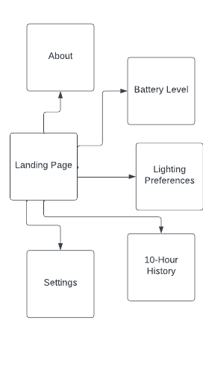

*Figure 1: A navigation map of the mobile application is shown above.*

Upon opening the application for the first time, the user will be met with the Landing/Home screen of the interface, showing the project name in a custom designed logo. A screenshot of the home page is shown below:

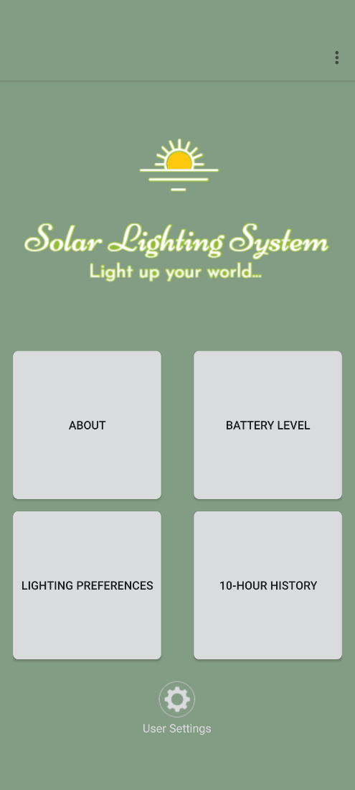

*Figure 2: The opening page of the Solar Lighting System mobile application.*

The landing page displays five silver buttons on a green background with white text throughout. Green and silver theming was primarily chosen to align with the eco-friendly and environmentally safe aspects of our project.

Each button on the home screen leads to a different page within the app. The first button navigates to the “About” screen, which provides a brief description of the project along with a small graphic depicting a solar panel:

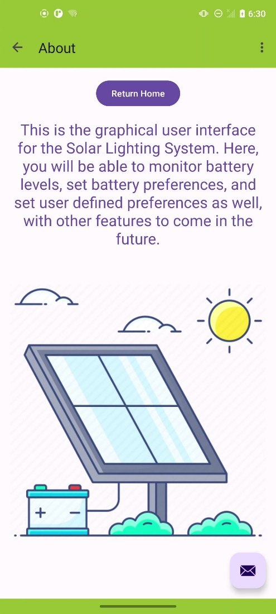

*Figure 3: The about page of the Solar Lighting System mobile application.*

Here a “Return Home” button is visible at the top of the screen along with a back arrow. Both buttons will take the user back to the Home page. These options are available throughout all subpages.

The next page is the “Battery Level” page, in which the user will be able to closely monitor the available charge on the battery of the Solar Lighting System:

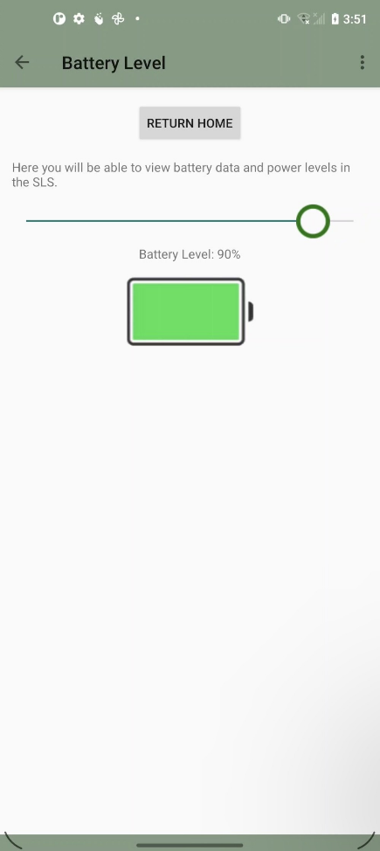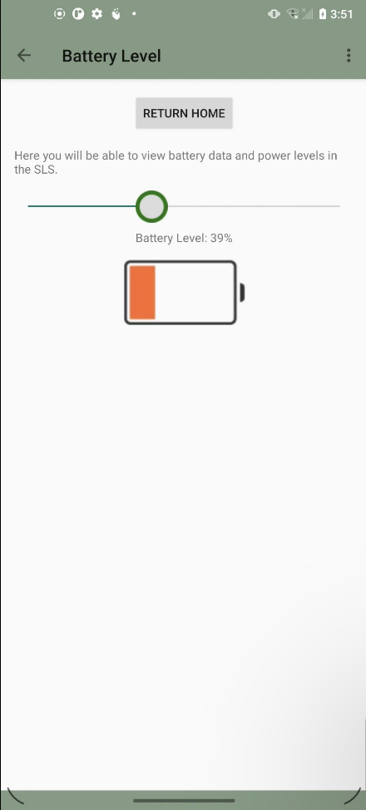

*Figure 4: Two side by side images of the “Battery Level” screen.*

Along with the text providing battery percentages of the system, a graphic is also provided to indicate how full or how empty the battery is with charge. The image updates live depending on the battery level given to the app from the microcontroller.

The third screen of the application involves the “Lighting Preferences” screen:

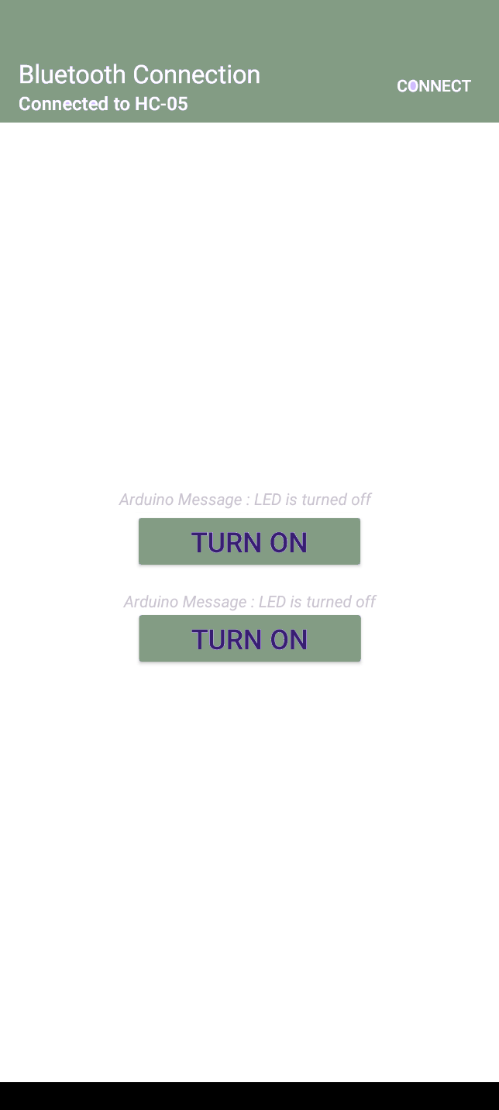

*Figure 5: The “Lighting Preferences” screen of the mobile application.*

This screen displays four sliders, each with their own preferences. Once there is stable connection to the microcontroller, this will give direct input into the system.

The final page of the application is the “User Settings” module:

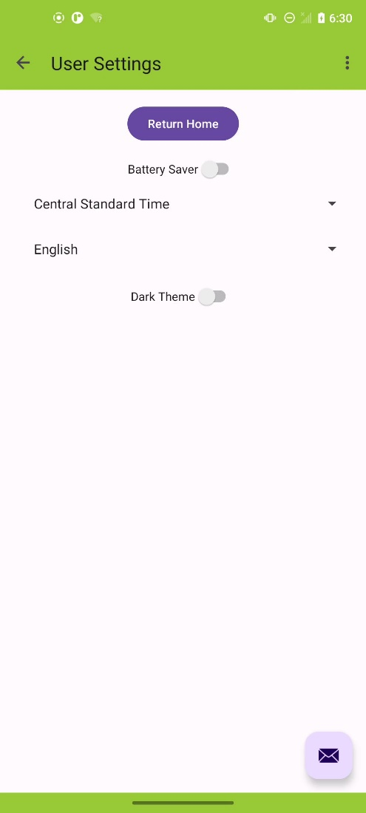

*Figure 6: The “User Settings” screen of the mobile application.*

Here the user can implement a battery saver mode into the system, input the date/time settings with a spinner, input language settings with another spinner, and activate dark mode if desired. Dark mode persists throughout the application, and is displayed below:

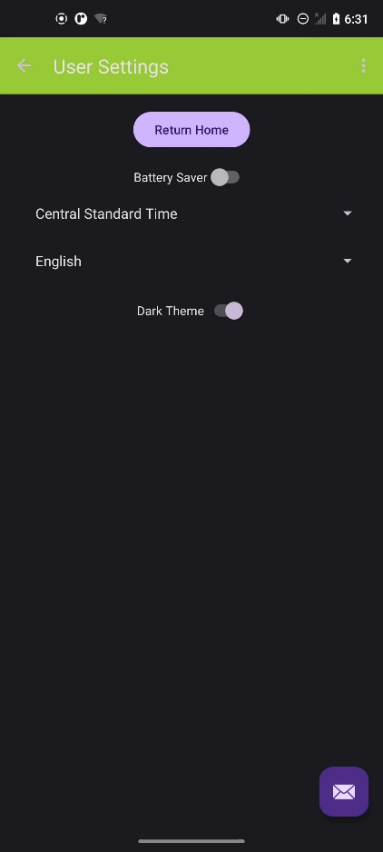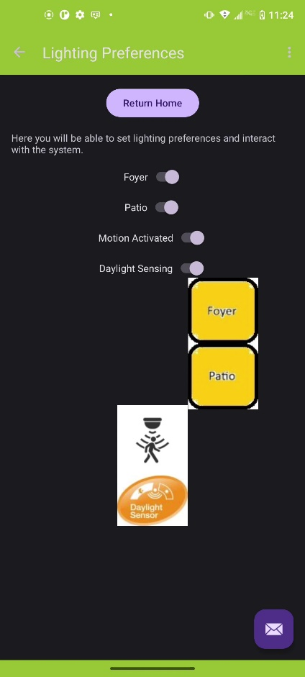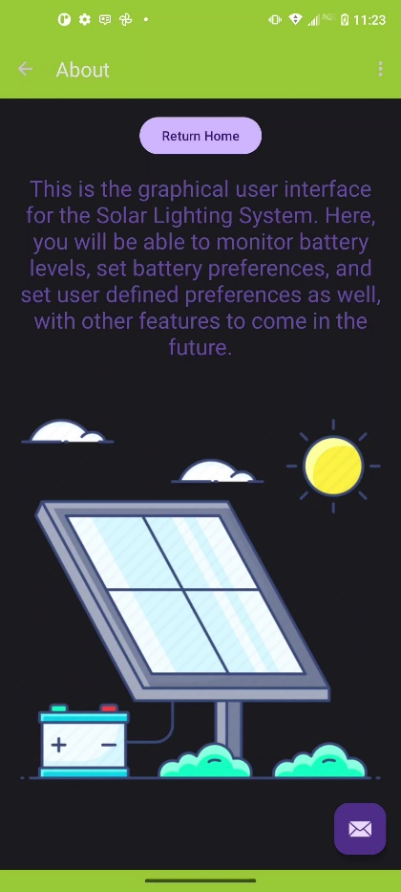

*Figure 7: Three side by side images, activated and persisting throughout the app.*

# Application Validation

# All of the previously described features are optimized and perform well. Testing indicated no significant bugs despite small UI improvements, and there were no crashes to report as well. A few things to be implemented include the Date/Time spinner the application.

BLE connection to an R3 Uno Arduino board was attempted through the use of the HC-05 Bluetooth module and succeeded.

# Application Conclusion

In conclusion, the Solar Lighting System (SLS) stands as an advanced solution with its tailored mobile application, specifically crafted for Android devices. Developed using Kotlin on the Android Studios platform, this application serves as the central hub for user interaction within the SLS framework. The seamless integration fosters a user-friendly experience, allowing individuals not only to control and manipulate the system but also to receive real-time updates and data from the SLS.

SOLAR LIGHT SYSTEM

Lyric Haylow

**Battery Charge Controller Subsystem Reports**

REVISION – Final

**1.** **Battery Charge Controller Introduction**

***1.1.*** ***Subsystem Introduction***

The Solar Lighting System will be powered exclusively by two solar panel cells, fed to a 12V 18Ah battery that will feed the rest of the system the power necessary. Since the system is expected to be powered solely by solar energy, an appropriate solar panel and battery were chosen to ensure there would be enough power for the system at any point in time. To ensure that the battery is charged efficiently and that it doesn’t get overcharged, a charge controller for the solar panel is necessary.

## 1.2. Subsystem Details

To ensure power is safely supplied to the battery, I chose a solar charge controller that would accommodate our chosen solar panel supply voltage, as well as our battery charge current limit. A block diagram of the subsystem is shown below.

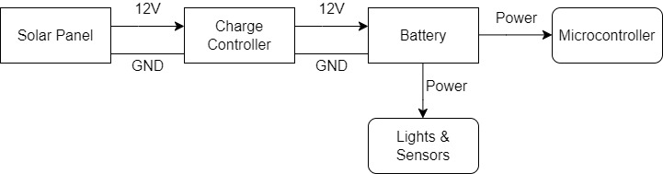

*Figure 8: Block Diagram of Solar Panel subsystem*

For this purpose, I’m using TI’s BQ24650 Typical Application design for a Stand-Alone Synchronous Buck Battery Charge Controller. This chosen design with the BQ24650 meets the requirements for this subsystem, though it was necessary to change some component values to match the specifications of the solar panels and battery used. The solar panels we’re using are Sunforce Model 58032 Solar Battery Chargers. Since we will likely be having a draw of power during the night to keep the small patio light on at all times during the night, we decided to use 2 solar panels to ensure that the battery is charged fully over the day. The Sunforce Model solar panels are 12V, with a 1.2A supply. The BQ24650 can have an input voltage of up to 28V, however since we want to charge a battery as efficiently as possible, we’re going to wire the 2 solar panels we have in parallel to increase the supply current. That input voltage and current will then be supplied to the Charge Controller Schematic as shown below

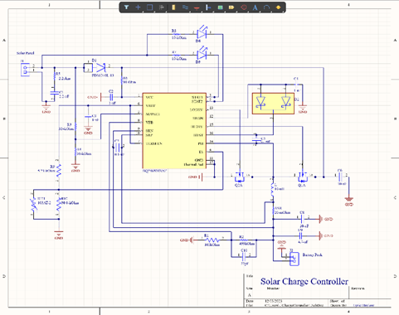

*Figure 9: Solar Charge Controller Schematic*

For the changes made to accommodate the solar panels, the regulation voltage that goes into the MPPSET pin is set by the following equation, with the MPPSET pin regulated to 1.2V.



To match the supply voltage of 12V, R3 was changed from 499kOhm to 324kOhm. The second value that will be subject to change would be the charging current to the battery from the IC. The full-scale differential voltage set between pins SRP and SRN is fixed at 40mV, so as shown in the equation below, the charging current can be set by choosing an appropriate resistor.

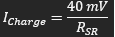

The default application provided by the TI documentation set the charging current to 2A with a 20mOhm resistor, however the battery obtained has a maximum charging current of 5.1A. Considering this, once the board has proven that it can work as designed with a singular 20mOhm resistor for a charging current of 2A, another resistor will be applied in parallel to jump the charging current to 4A. Charging current is the most important factor for quickly charging a battery, so should we be able to maintain a 4A output current, then that would be our best point of action.

To know whether the board is charging or not, there are two LEDs in the design which are set to light up on certain conditions. Pin 3 is connected to STAT1 and will light up to indicate that charging is in progress. Pin 5 is connected to STAT2 and will light up to indicate that charging is complete. Testing on the board will mainly comprise of ensuring that the LEDs light up, as well as checking validations.

***1.3.*** ***Subsystem Problems & Solutions***

As the subsystem currently is, it is unsure whether it works. When testing the board before demo, the PCB board designed was attached to the battery, and the resulting current draw demanded from the battery overheated several traces on the board and caused them to burn out. Since no real results could be derived from the PCB board since then, this part of the subsystem report will cover more of what problems were noticed, how to fix them, and proposed solutions with plans going forward.

The Printed Circuit Board designed is shown in the Figure below. Several parts from the original design it was inspired from were changed and omitted as necessary. For instance, the Q3 component is not included in this design, as it was deemed unnecessary.

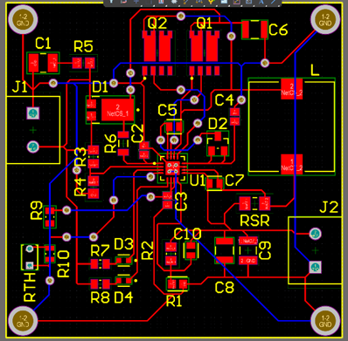

*Figure 10: Charge Controller PCB Design*

**1.3.1.** ***Problems Identified & Solutions***

The primary issue with the design that resulted in traces being burned out was simply that the traces on the PCB were too small. I had designed the PCB with only layout in consideration, and not paying appropriate attention to the trace widths. To remedy this issue, I had decreased charging current going to the battery to ~0.5A by using a 0.09Ohm resistor as my RSR component. The 5mil trace set for the input current could handle a low current supply, and the plan was to test the board with a small input and small output, to see whether the LED set to indicate charging would light up. Attaching the battery first, without a supply voltage ready to feed into the battery, resulted in a draw current that exceeded what 5 mil traces were capable of carrying. To account for this problem, a new PCB design will be made with appropriate trace sizes for relevant sections. Several other fixes will also be implemented to help ensure the new Charge Controller PCB works better than desired.

* Since the input current from the solar panels will be ~2.4V, the trace size for the Net attached to Vin will be set to 30 mils. That would provide accommodate 2.4V, as well as provide some leeway.
* Charge current to the battery would be best set to 4A, so 45 mil traces to accommodate this current would be set to the net corresponding to all traces attached to Vout. A complete redesign of component placement will likely be necessary to implement this change. Figure __ shown below is the result of not having sufficient traces, and the highlighted spots specifically show the problem areas.

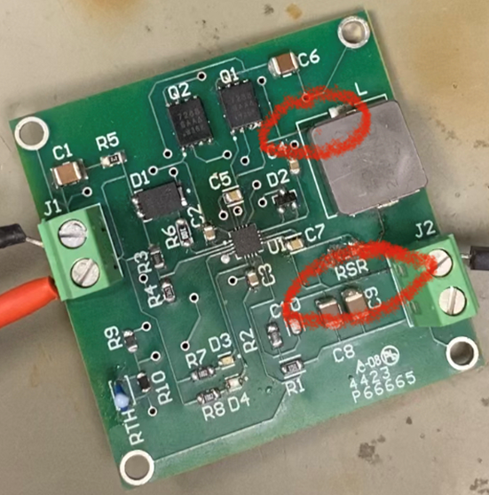

*Figure 11: Physical Malfunctioning Board*

* Though everything fit on a 2 inches^2 board, it made it very difficult to work any hotfixes necessary to be made. Once a number of components were placed, it also made soldering more difficult as well. The cost of the board also wasn’t decreased sufficiently enough to warrant decreasing the size of the board, so the new PCB design will likely greatly increase in size to make both soldering and spot testing easier. Traces that hold large amounts of current will likely still be kept small though, as the increase in resistance and voltage drop would be greatly detrimental there.
* Though a simple issue, none of the inputs or outputs in my board were labeled. That made it hard to identify where input and output wires were supposed to go, as well as spot check issues within the board. This is not necessarily a harsh problem, but adding silk screen text boxes would greatly improve clarity and prevent mistakes.
* Having traces overlap from different layers was also a potential issue I can across. Since it wouldn’t make sense to never overlap traces on different layers, as that would defeat their purpose, I will likely just reconsider the placement of traces that could result in heating issues. With the large amount of current traveling through my board, ensuring that there are no unnecessary hot spots located on the PCB would help alleviate potential future issues.

***1.3.2.***  ***Plans Going Forward***

Going forward, the plan is namely two actions that should ensure that I have a working board around when 404 starts. I’ll be spending most of my time this winter in CSTAT, so I’ll have plenty of time to use the relevant equipment needed.

1. First action would be to use a perfboard with a 16pin footprint to test the design of the charge controller. One of my concerns regarding my design is that I was unable to test whether it would’ve worked properly for its intended purpose. As far as I’m aware, the board may have further complications that could inhibit it from working properly. To alleviate those concerns, I plan to buy a few sets of components that are through pin and several perfboards, to then test the validity of my design over the winter. So long as I keep the output current appropriate for the traces on the perfboard, this idea should work well to either identify further issues or prove that my design works and how I can further validate it works as intended.
2. My second action, that will in part be in progress while I work on the perfboard, would be to design a new PCB board with my planned improvements. I’ll design this board at the same time perfboard testing is underway, that way if I decide components, footprints, or placements need to change, I can freely do so before I order the new PCB. Once I’ve validated my design using the perfboard and decided I’m happy with the new PCB design, I’ll order it with the appropriate components. I hope to order the new PCB from new years to the first week of January, to then be put together once it arrives.

For potential budget concerns, I’m not too worried since the majority of our budget expenses have been covered by already having relevant products for our project. Both solar panels and batteries were obtained from prior projects, so our total budget should be able to withstand some extra expenses for the sake of validity.

***1.3.3. Validation***

The included validation plan has been updated according to the changes I’ve made with the PCB board. As the subsystem is still in progress, nothing has yet been validated. The relevant validation procedures are provided below.

|  |  |  |  |
| --- | --- | --- | --- |
|  | Test Name | Success Criteria | Methodology |
| 3.2.1.1 | Solar Panel Mount | Stays in space mounted for several days time | Verifying Hardware is properly mounted |
| 3.2.1.2 | MPPT Functionality | MPPT is working as expected within the IC | Set higher voltage than MPPT, check whether IC brings voltage down to set MPPT voltage level. |
| 3.2.1.3 | Charge Controller Verification | Voltage levels are modulated along with Current Levels | Steadily increasing current will be applied to charge controller, to point of max expected |
| 3.2.1.4 | Overvoltage Solar Panel Protection | Supply voltage levels do not exceed IC limits | Sending a increasingly higher voltage through the charge controller, eventually checking it functions as predicted |
| 3.2.1.5 | Overcurrent Battery Protection | Charging current levels do not exceed expected input values | When charging battery, consistently measuring charging current upon increasing supply voltage using DC power supply |
| 3.2.1.6 | PWM EMI Interference | Interference does not significantly alter design guidelines | Use a Broadband RF meter if one available, if not then the Oscilloscope to identify interference points. |
| 3.2.1.7 | Battery Charging to Capacity | Battery stops being charged once it has a full charge | Feeback voltage will be applied back to IC as shown in documentation |
| 3.2.1.8 | State of Charge (SOC) | Measurement for current State of Charge coincides with expected values | Measure the voltage with a multimeter and convert measured voltage to approximate power percentage expected |
| 3.2.1.9 | Depth of Discharge (DOD) | Measurement for current State of Charge coincides with expected values after discharge | Measure the voltage with a multimeter and convert measured voltage to approximate power percentage expected |

*Table 1: Validation Tests for Solar Charge Controller*

***1.4.*** ***Subsystem Conclusion***

Currently, the subsystem is still in progress towards completion. A minor setback resulting in a malfunctioning board has set this subsystem back, however plans to test just the design on a perfboard, as well as to make a new PCB to accommodate all the changes learned from the first board are in place as well as motion. Ensuring that a consistent and reliable amount of power is supplied to the other subsystems is crucial to this project, and by this upcoming January a working subsystem will be made.

SOLAR LIGHT SYSTEM

Jeb Malek

**Power Inverter Subsystem Report**

REVISION – Final

3 December 2023

1. **Inverter Introduction**
   1. ***Scope***

This subsystem entails the hardware and software design, PCB manufacturing, and assembly for the power inverter of the solar light system.

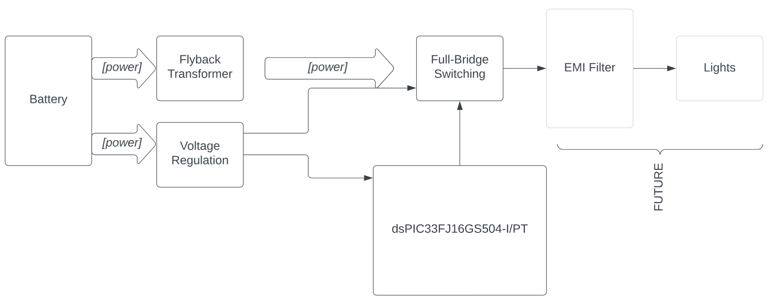

*Figure 12 Power Inverter System Diagram*

* 1. ***PWM Controlled Pure Sine Wave Inverter***
     1. **Carrier & Modulation Signal**

In order to create a utility grade output power supply from a DC battery resource a DC to AC sine wave inverter is needed to raise voltage levels, convert current waveforms, and ensure steady smooth voltage outputs with constant periodicity, or stable frequency.

A 24V input is designed for and will be sourced from a DC battery bank. In order to complete conversion of current waveforms from direct to alternating a sinusoidal reference is used to compare a signal with a characteristic triangular wave known as a modulation signal to create a sinusoidal pulse width modulation signal for switch control and current polarity inversion. \

Calculations can be done to monitor efficient output and verify tolerances set by power electronic professionals. From the fundamental power equation below harmonic analysis will be performed.

$$P_{out}= V_{out}\cos{ωt ∙I_{out}\sin{ωt} }$$

1. **Inverter Details**
   1. ***Battery Source***

Supplying a DC voltage source will be done with a 2 12 V Lead Acid Battery Pack will provide lower primary to secondary current draw as less amperage is needed to convert to the 120 V nominal value needed for switching and output stages. Sealed battery packs offer robust use and ease of long-term storage. Durability and cost are the main design factors contributing to selection of the *Interstate 12 V Sealed Lead Acid* part. Steady voltage sources are crucial for switching smoothly for an efficient output. Without voltage feedback systems, overvoltage detection, AC current sensing for short circuit shutoff and amperage limitation.

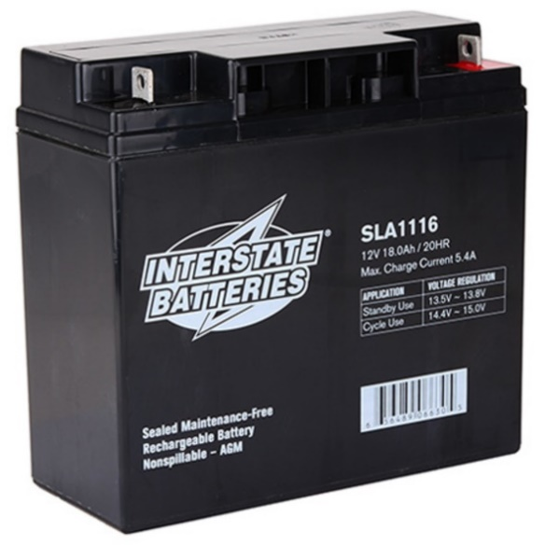

*Figure 12V Battery Image*

* + 1. **Voltage Regulator**

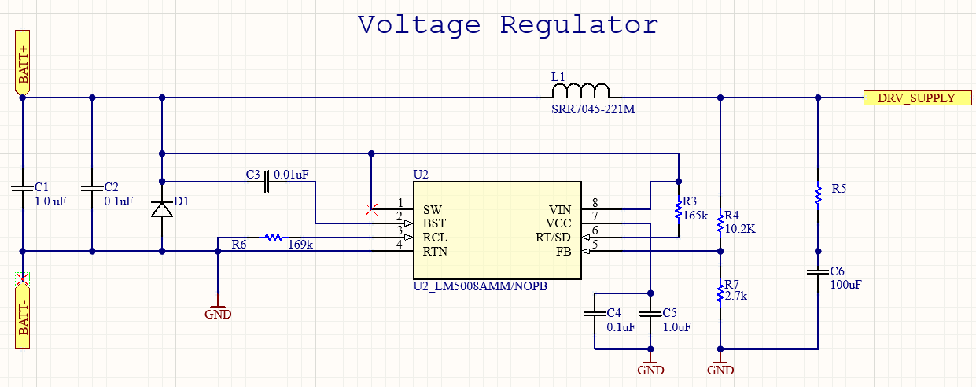

*Figure 13 Voltage Regulator, Continuous Output*

Battery input regulation is initially stepped down with a switching regulator from *Texas Instruments ,* providing a

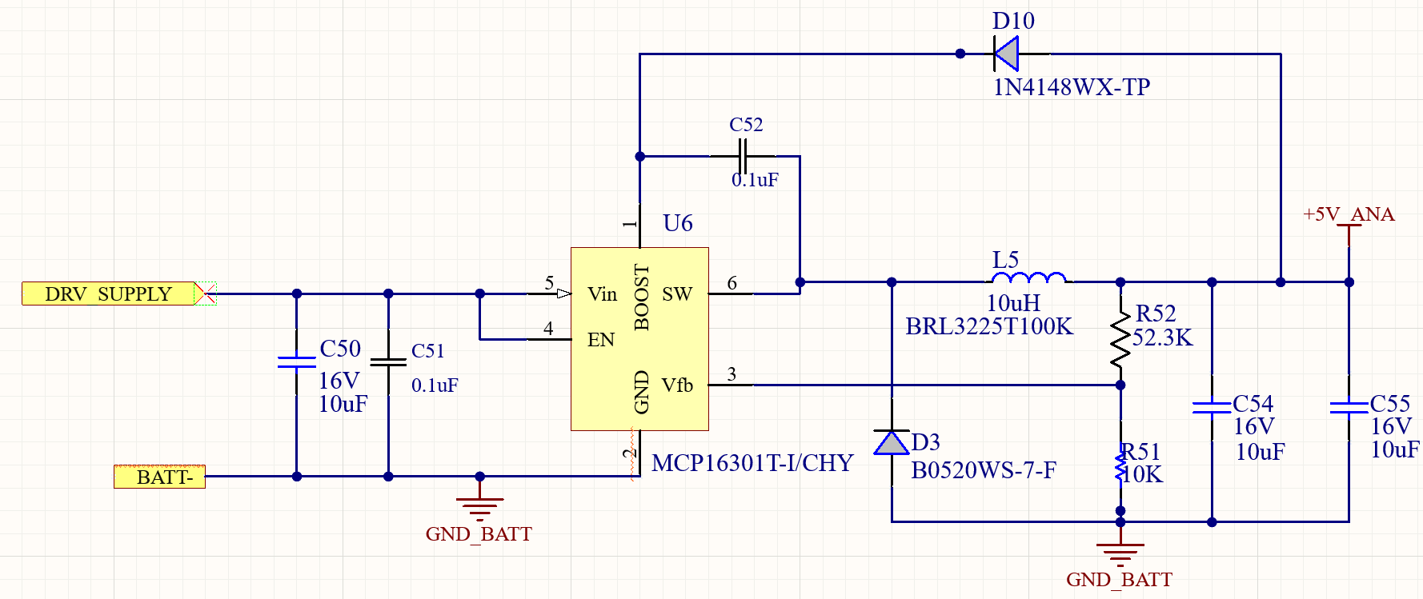

*Figure14 5V Power Supply Regulation*

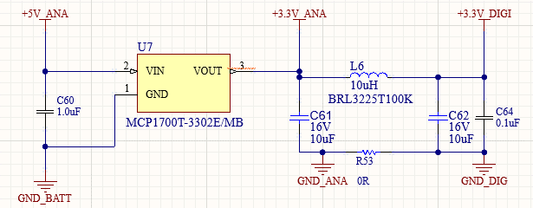

*Figure 15 Buck Switching Regulator*

To properly power integrated circuits on this inverter board the Low-Dropout Voltage Regulator is used for low current DC/DC conversion. Decoupling capacitors are placed on each output with the effort to ensure smooth DC voltage supply to circuits in this design.

A switching regulator is not necessary in this application as the efficiency of low voltage circuit powering is not as great of a concern in the scope of this project.

* 1. ***Switching***
     1. **Duty Cycle Modulation of PWM Gate Driving**

In initial research a decision of controlling MOSFET power switches with unipolar square wave pulse generation versus bipolar switching control for an efficient solution for a cost and component conservative design.



Figure 16 Theoretical SPWM

A MATLAB Simscape Control Topology can be seen below with results showing triangle wave carrier wave generation for comparison with the modulation signal.

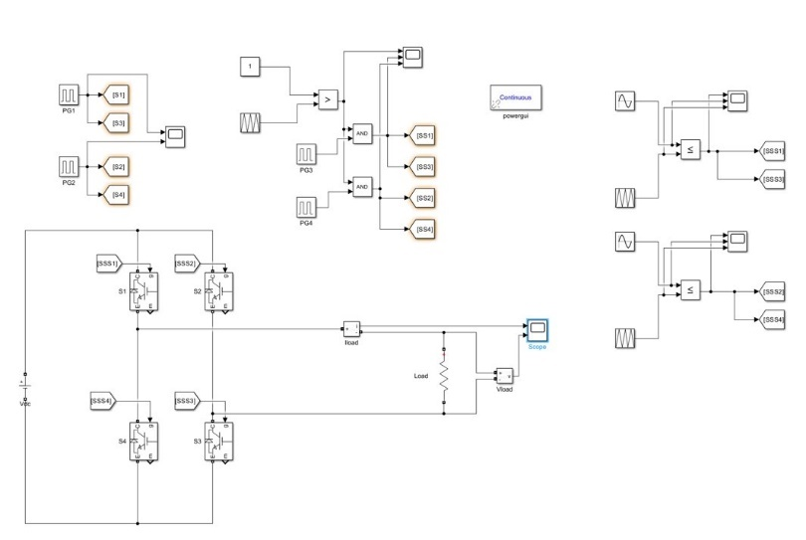

*Figure 17 MATLAB Full Bridge SPWM Simulation*

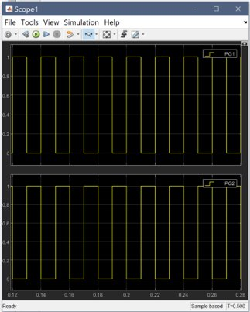

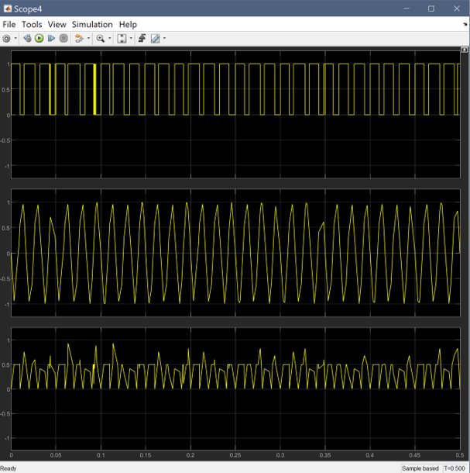

*Figure 19 Output Simulation of Ohmic Load*

*Figure 18 Dual Channel PWM / Full Bridge Control*

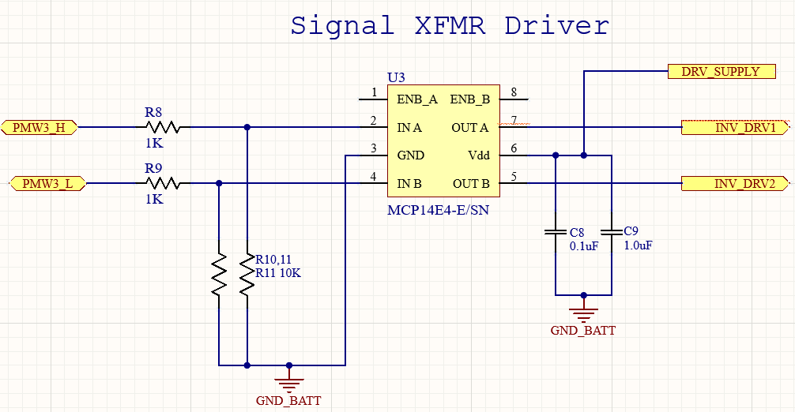

*Figure 20 Signal Transformer Circuit for Full Bridge Driving*

A *MCP14E4-E/SN*  is used to provide a stable switching frequency for the signal transformer to operate in the intended purpose.

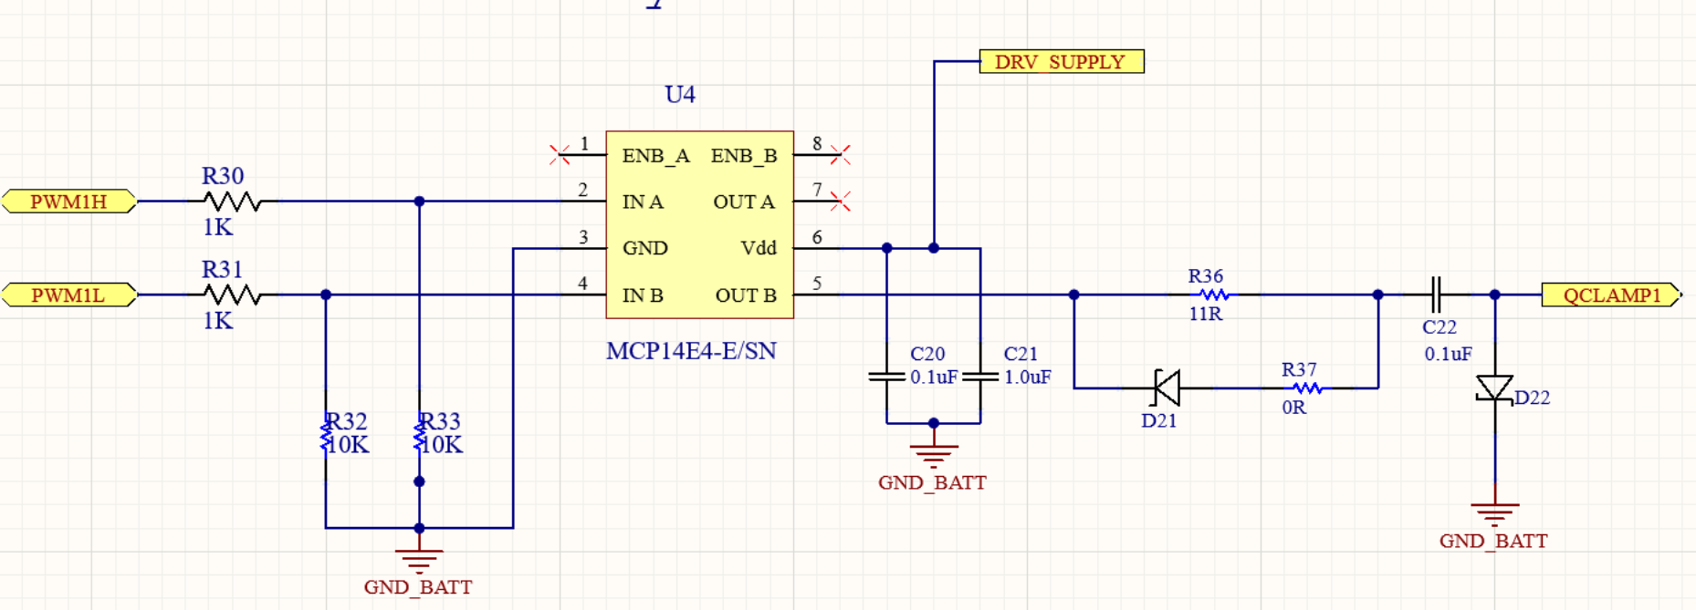

*Figure 21 Flyback Driver Schematic*

*Figure 23 Flyback Driver 2*

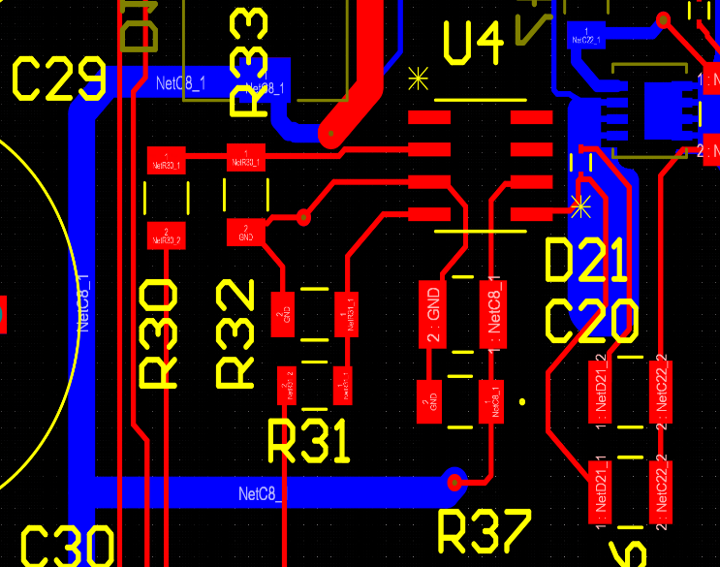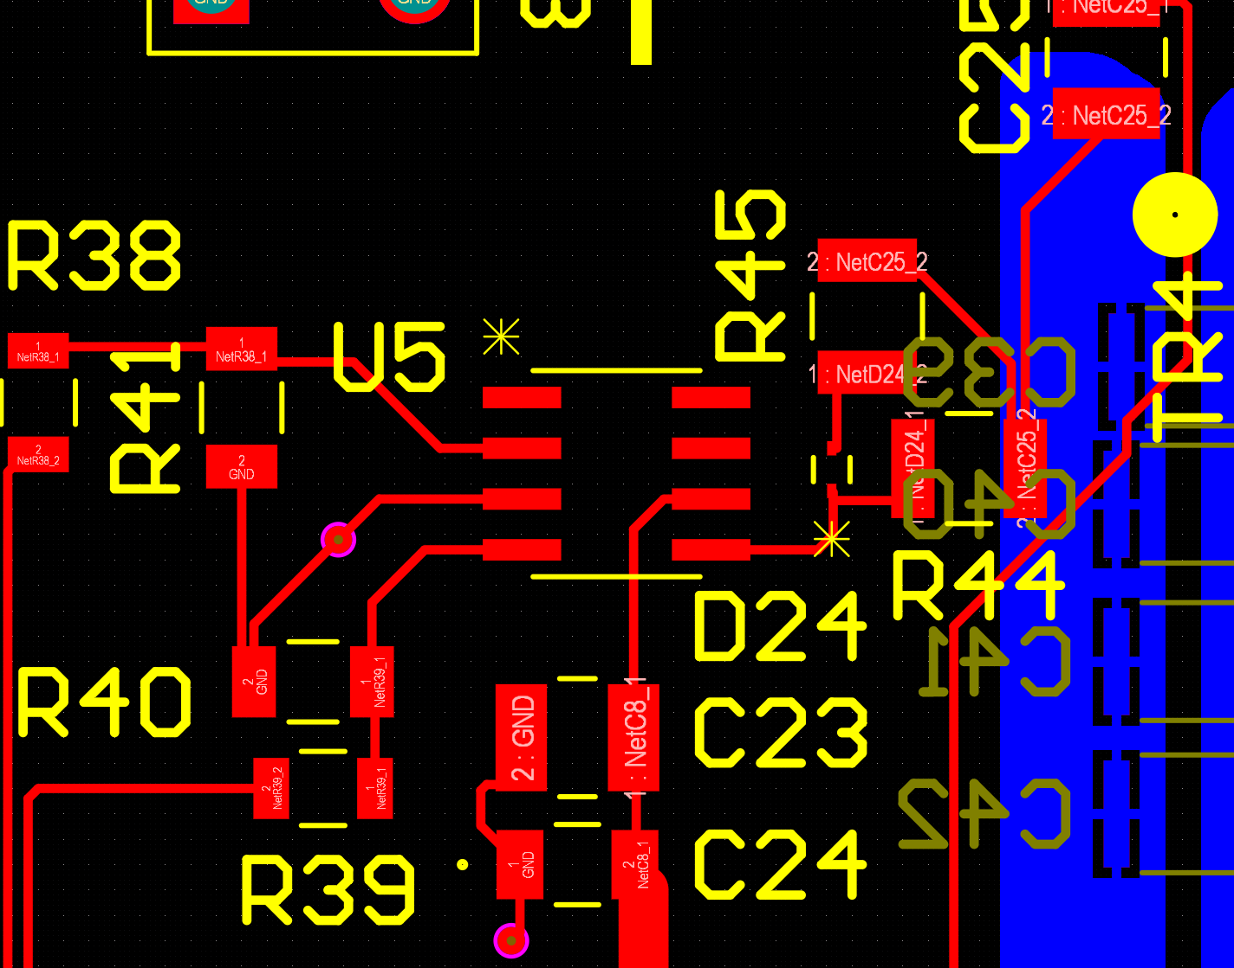

*Figure 22 Flyback Driver 1*

Each flyback driver is used to enable the proper functionality of the interleaved switching nature of the flyback converter.

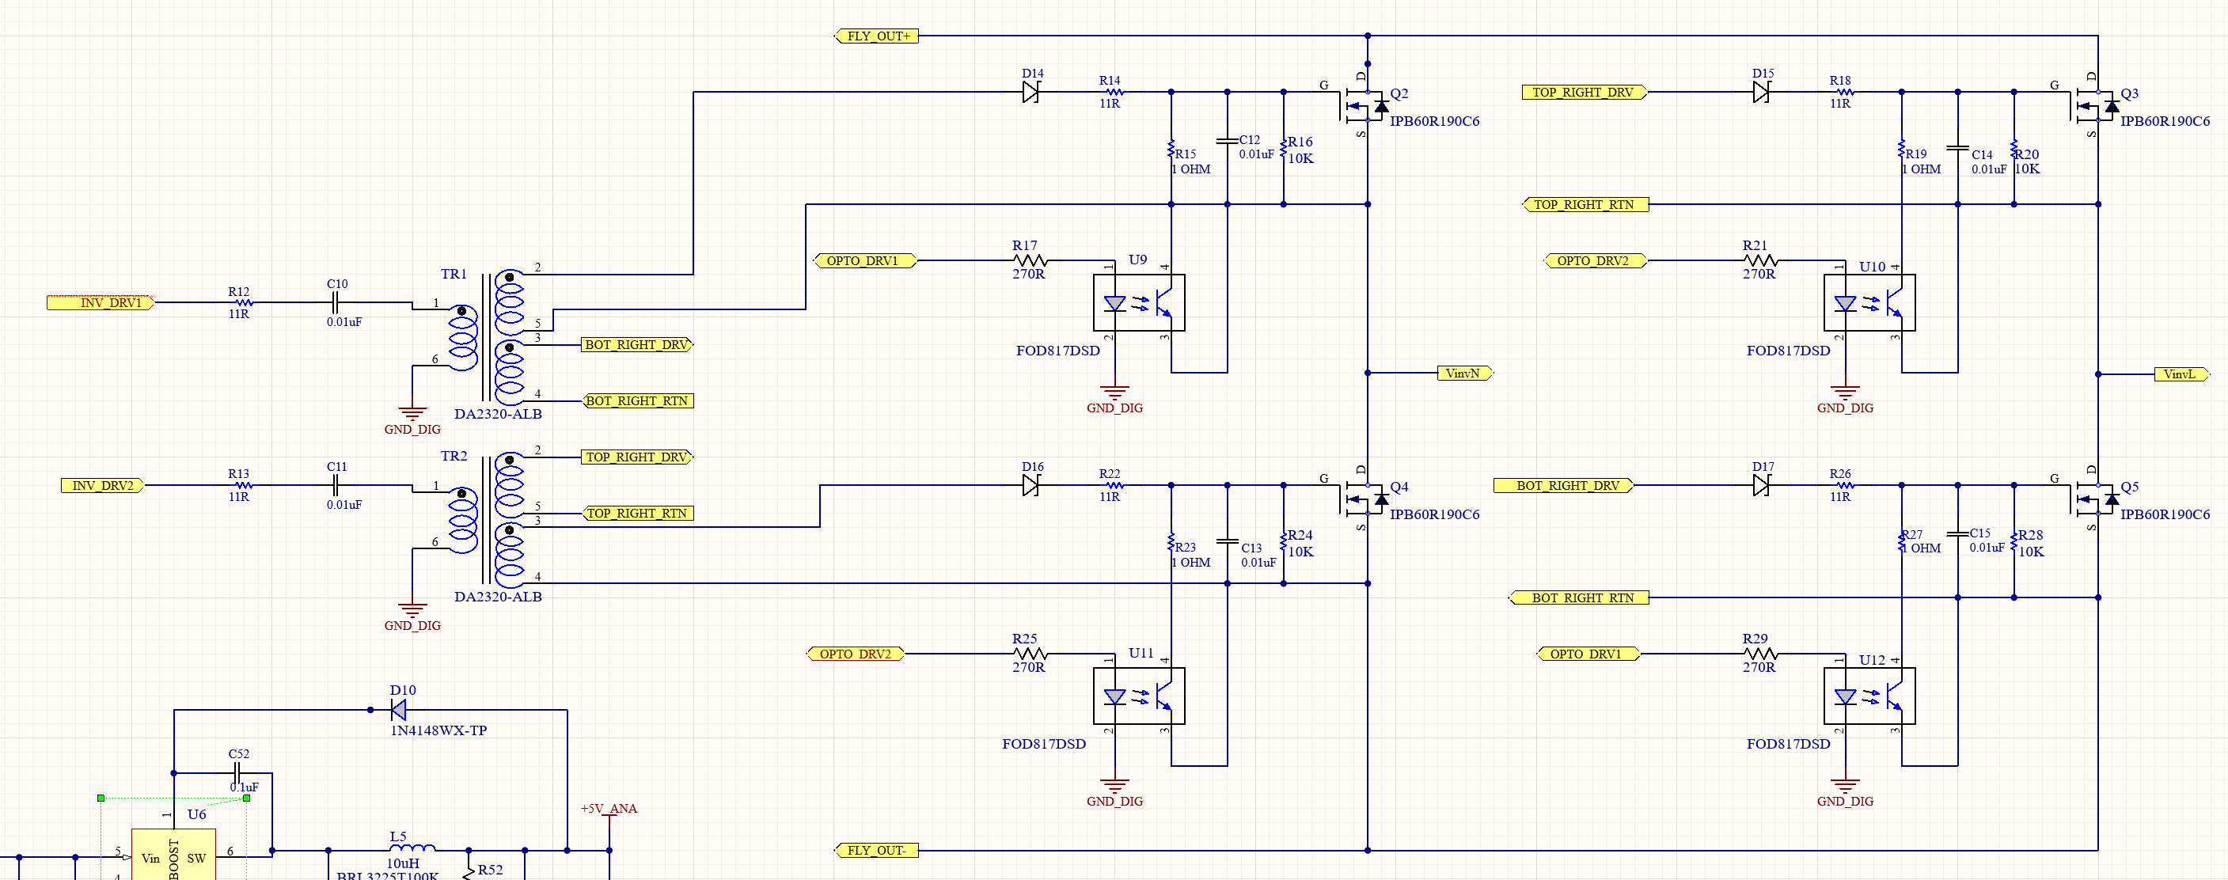

*Figure 24 Full Bridge Switching Schematic*

*Figure 25 Half Bridge Q2-Q3*

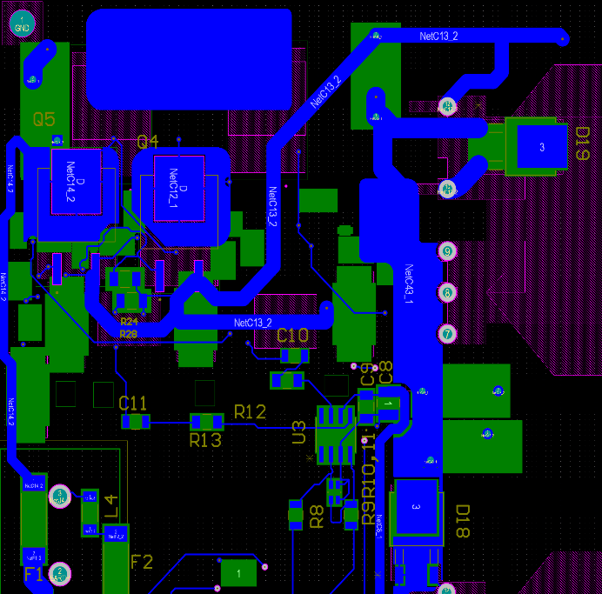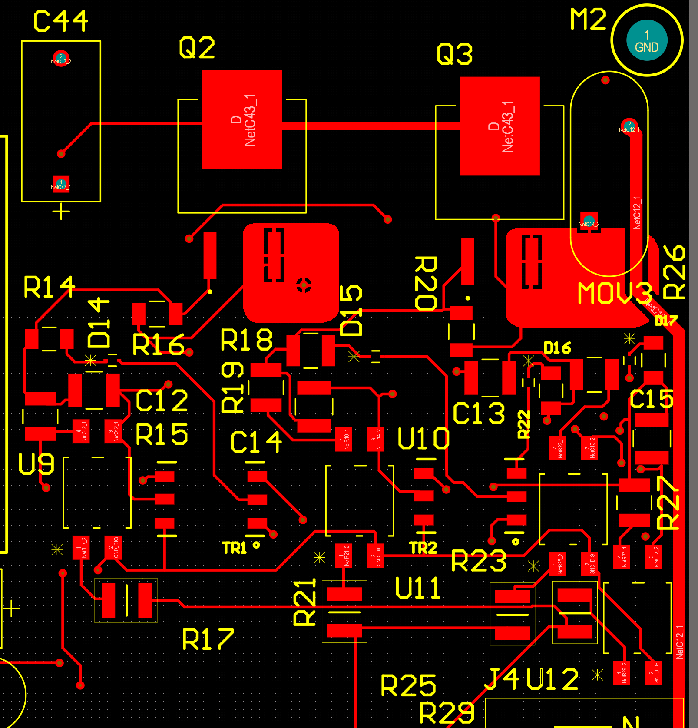

*Figure 26 Half Bridge Q4 Q5*

The Full-Bridge schematic and PCB lay above highlight the use of signal transformers *TR1* and *TR2* to create driving signals to two separate bridges of MOSFET power switches, By efficiently switching polarity during positive and negative half cycles a load can see both positive voltage from the source and negative voltage. In the Unipolar Sinusoidal Pulse Width Modulation signaling that is being driven into respective MOSFET gates the intended half bridge will commutate correct current flow for positive and negative half cycles.

* 1. ***Digital Signal Processor***

Shown below are schematic symbols for the components used to facilitate gate driving logic.

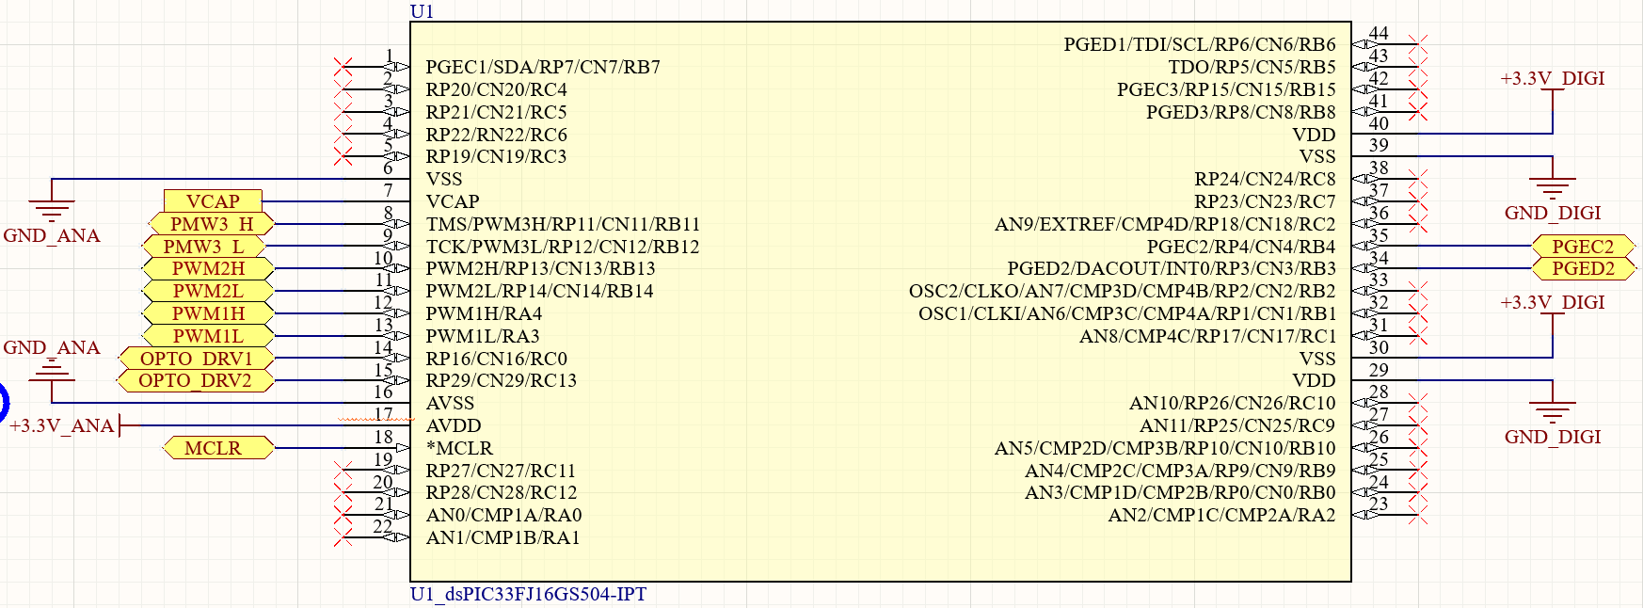

*Figure 27 Digital Signal Microprocessor : dsPIC33FJ16GS504-I/PT*

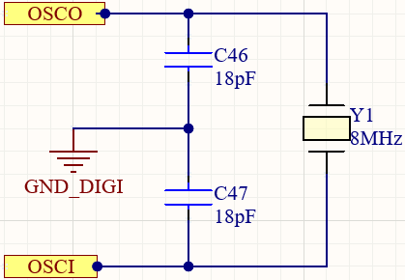

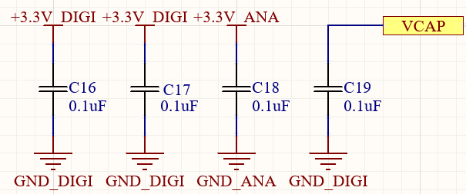

*Figure 28 Decoupling Capacitors for Voltage Inputs*

*Figure 29 External Crystal Oscillator for Carrier & Modulation Signal*

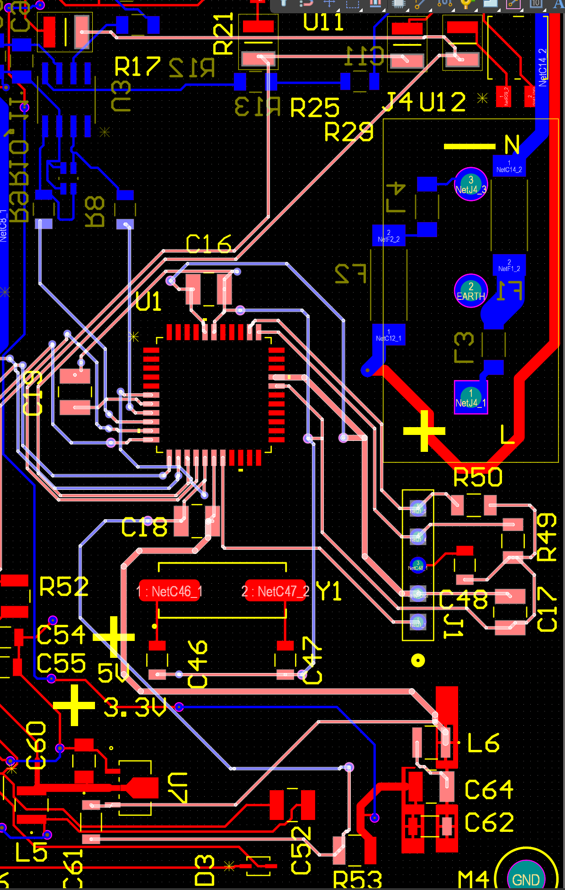

*Figure 30 PIC DSP 44 Bit TQFP Layout & Tracing*

The above graphic shows placement of the 44 pin package integrated circuit in a central location to receive necessary analog power from regulator circuits as a power source. Shown also are the various signaling traces used to control gate triggering of the power MOSFETs used in voltage conversion. The precise pulse width modulated signals from Microchips dsPIC series allows for programmable control of output characteristics waveforms.

* 1. ***Transformer***
     1. **DC/DC Conversion Topology**

Positive half cycle and the repetitive polarity inversion for negative half cycles are handled by the converter circuit shown below.

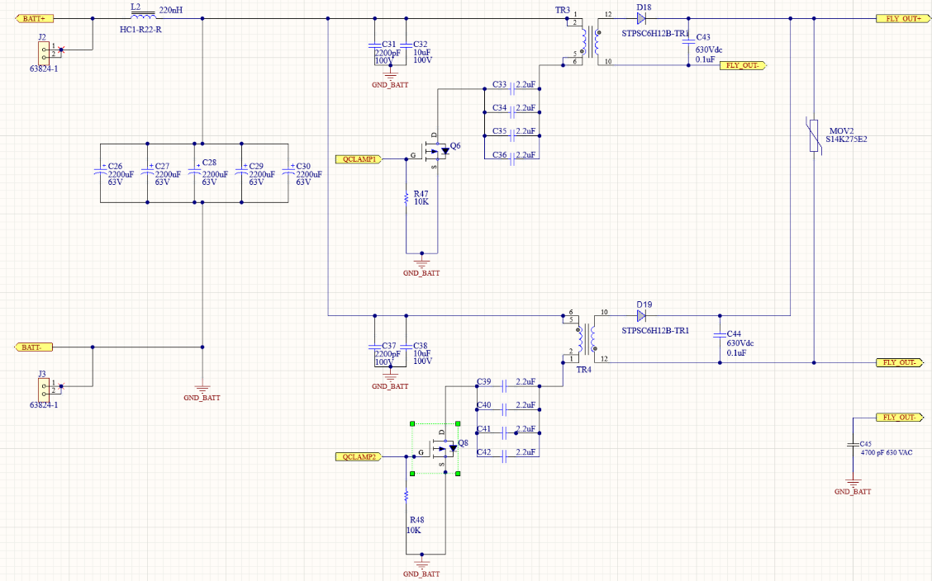

*Figure:31 Interleaved Flyback Transformer Schematic*

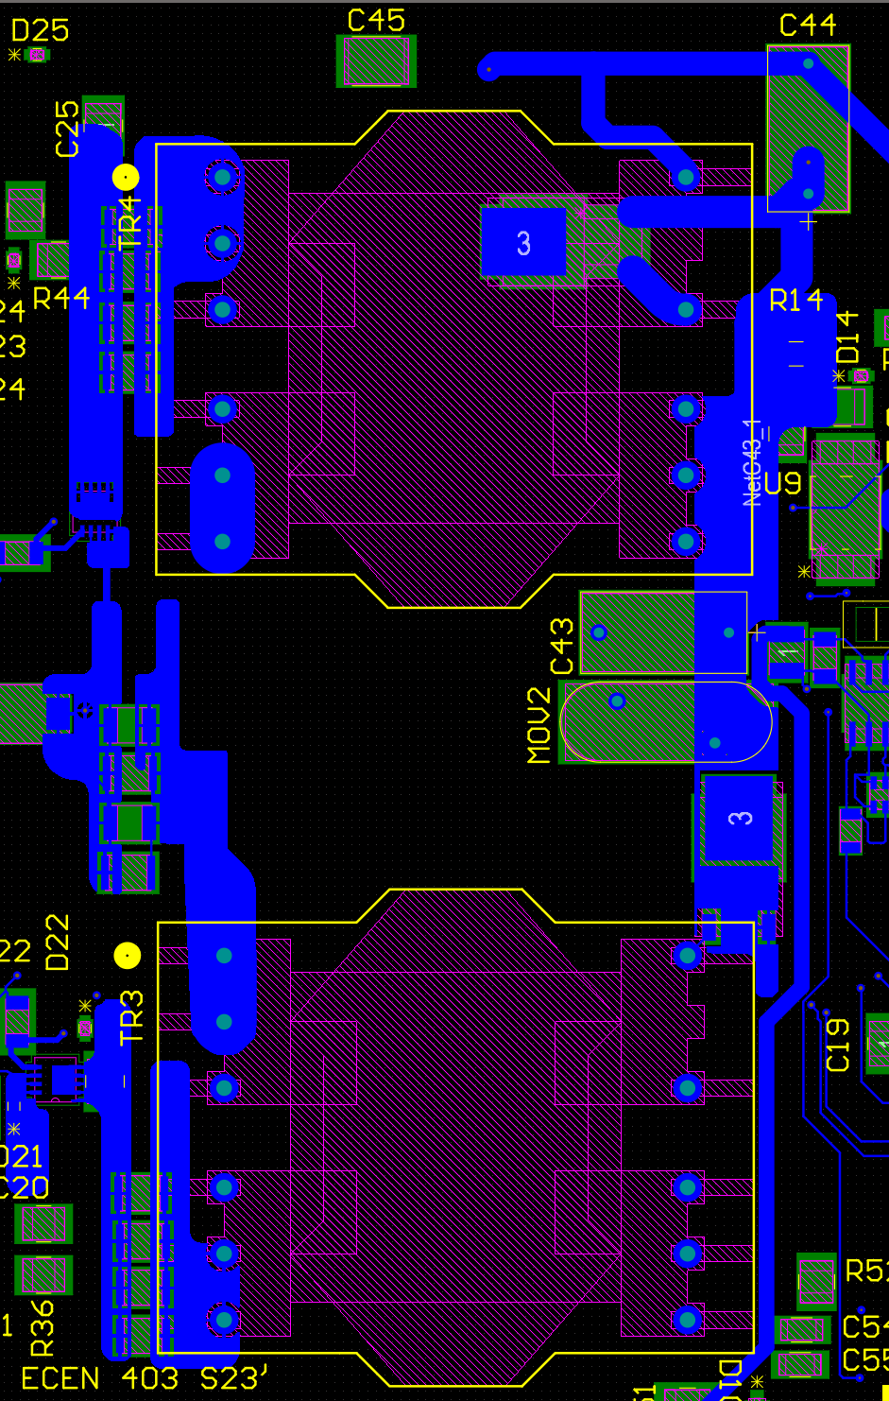

*Figure 32 Flyback Converter Layout*

1. **Inverter Validation**
   1. ***Microcontroller Programming***
      1. **ICSP (Inter Circuit Serial Programming)**

To program the digital signal processor package with the correct modulation signals and external oscillation functionality the PICKit3 will be used to validate correct binary encoding for MCU processing of carrier/modulation signaling.

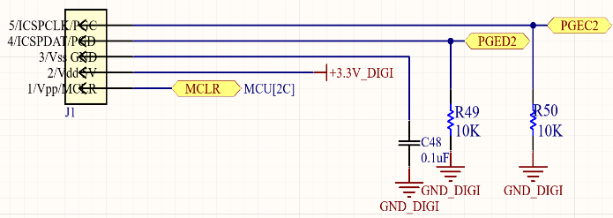

*Figure 23 3 ICSP Schematic*

*Figure 33 PICKit ICSP Header Layout*

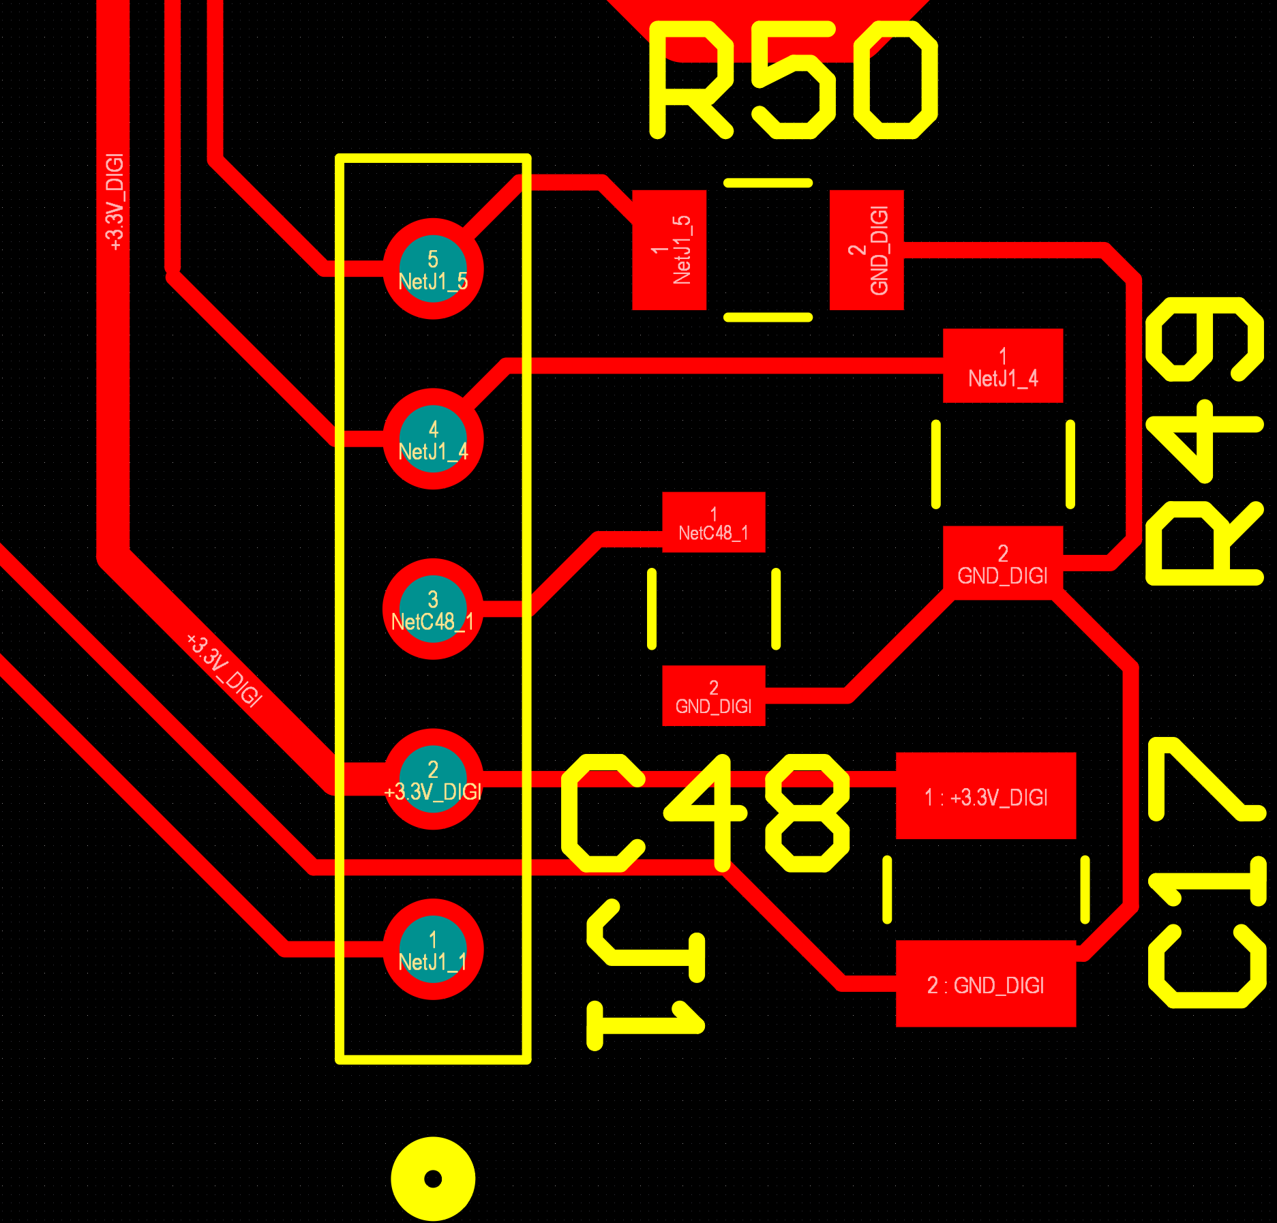

* 1. ***Full-Bridge Switch Control***
     1. **Gate Drive Signal, Half-Bridge Operation**

To generate a unipolar sinusoidal pulse width modulated signal SPWM

Oscilloscope measurements will be taken to verify gate driving signal timing is compliant with sinusoidal PWM logic. The presence of a Dead Time will validate safe switching practices for the

* 1. ***Sinusoidal Waveform from Oscilloscope***
     1. **Output Voltage Waveform**

Without an EMI output filtering feedback system the waveform supplying the load should have a ripple component at the frequency of the modulation signal. Verification of peak to peak timing of ripple component will prove modulation at this frequency.

* 1. ***Load Support***
     1. **AC Voltage Output Range**
     2. **Total Harmonic Distortion**

Following the IEEE 1547

Harmonic distortion is totaled with the RMS value of the harmonic components detected during measurement with respect to the fundamental component. The equation below is used to calculate a total value to compare with specification.

$$THD= \frac{\sqrt{H_{2}^{2}+H_{3}^{2}+…+H_{N}^{2}}}{H_{1, Fundamental}}$$

A spectrum analyzer procedure will be implemented to verify efficiency limits to comply with electrical class constraints.

1. **Inverter Conclusion**

Rated for 200VA , this inverter will be able to supply a large portion of a typical residential housing load, as there can will be a normal operating load around 45W with the minimum of 3 15 W LED Lights installed during the integration of subsystems.

In looking forward to the next 6 weeks of the execution plan a prototype board shipment will arrive , with three boards to perform testing on. Soldering procedures of small package components progressing to larger sizes will ease the assembly process and a cascaded validation plan will be implemented to verify each stage of this power inversion process. In reflection of this project’s initial stage of validation important decisions to fit a board size constraint of 30 square inches required unanticipated delay in board ordering schedule. Along with verification of design rule checks without any errors contributed to further delay in schedule. Progress towards prototype completion and consideration of thermal and efficiency improvements will be of focus upon subsystem validation.

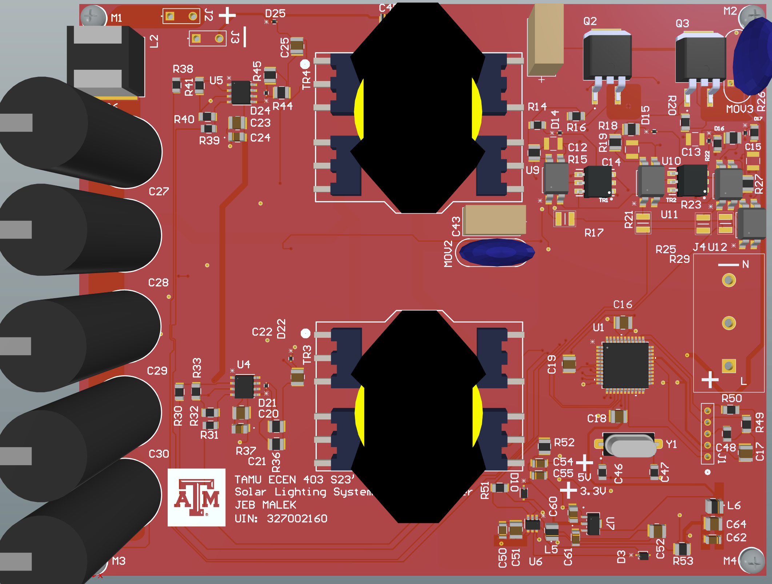

*Figure 34 Power Inverter Initial Prototype Design*

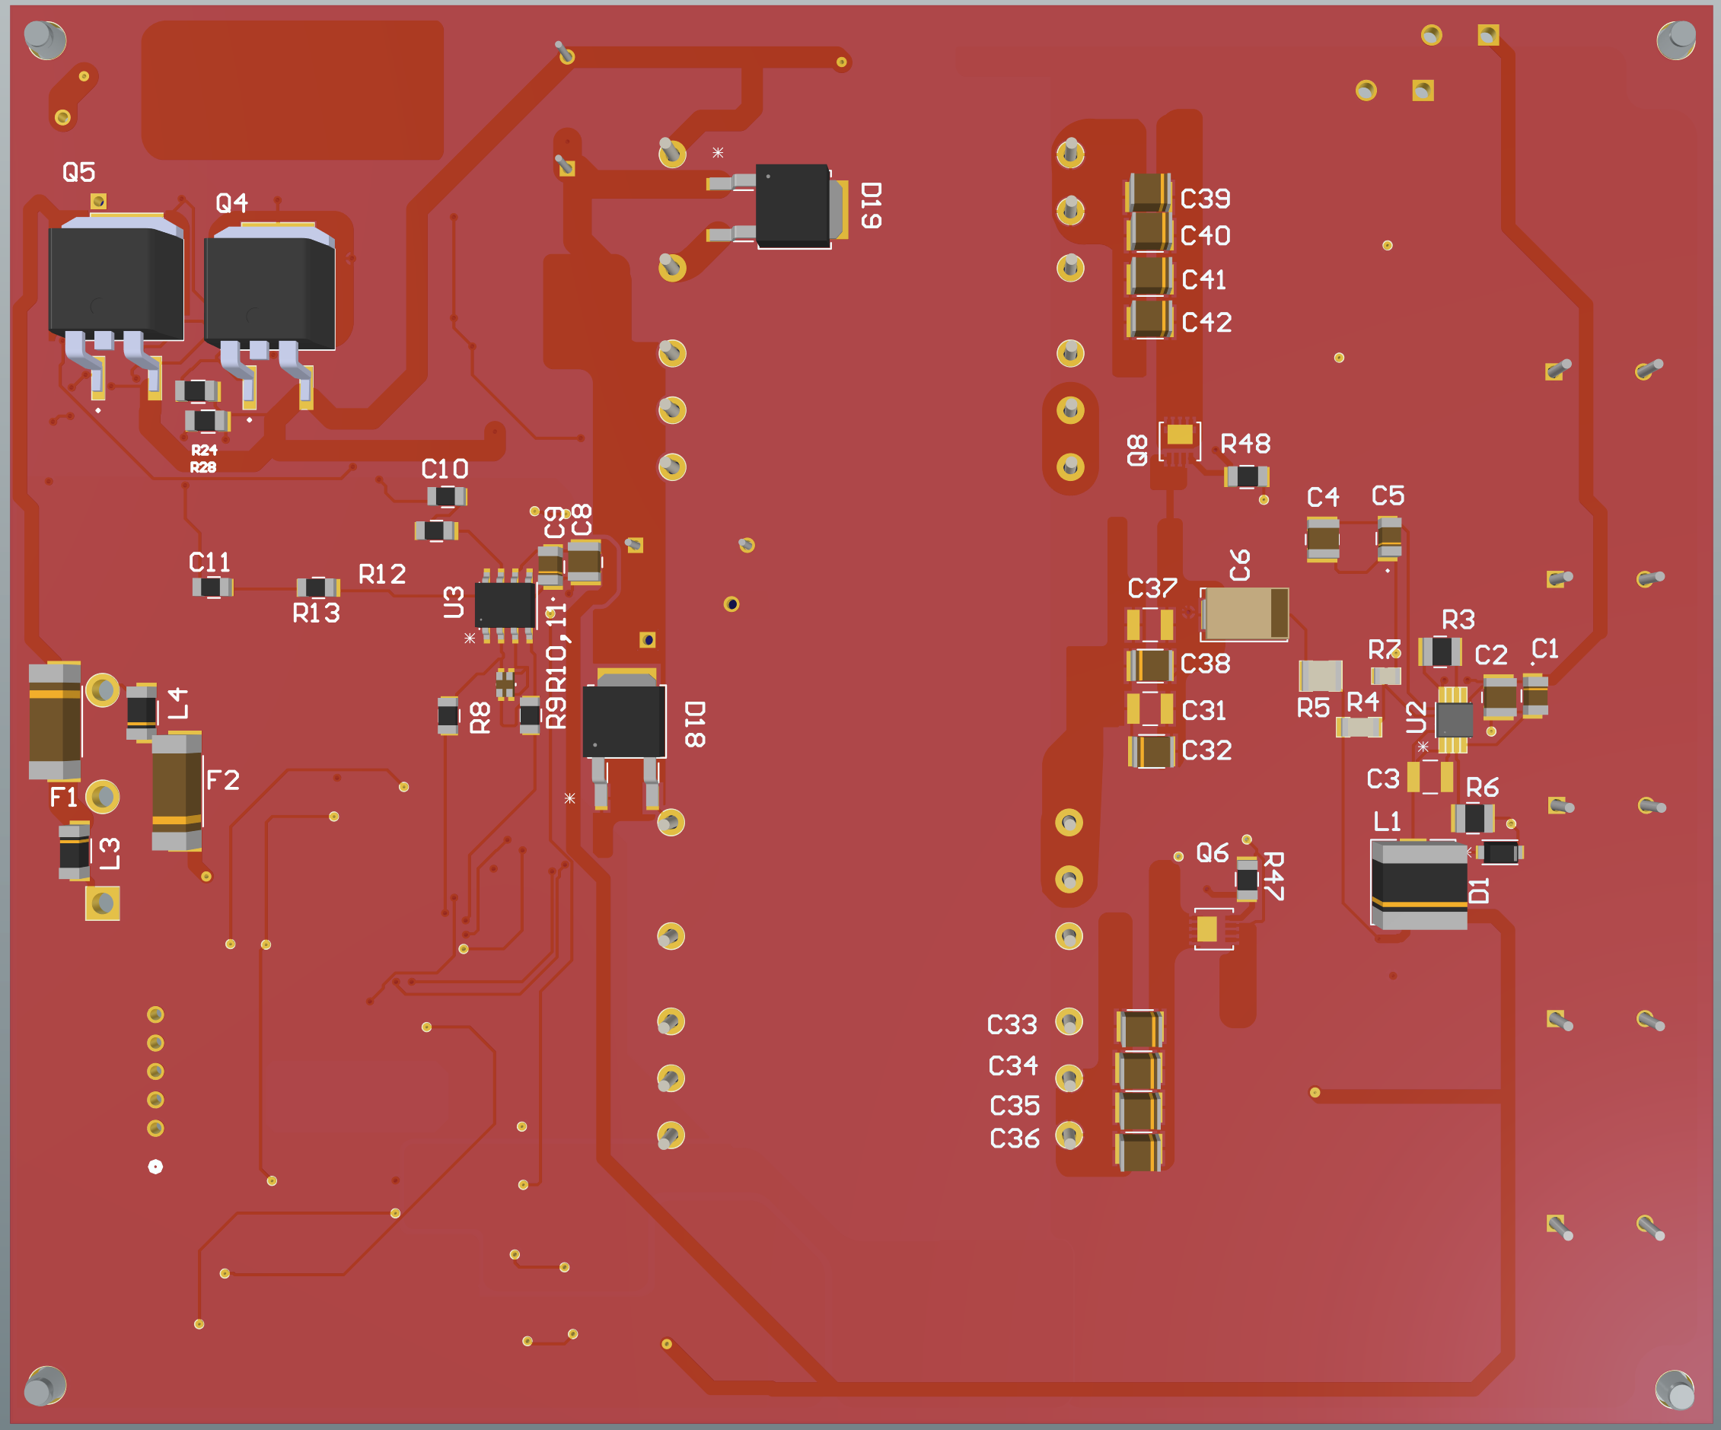

*Figure 35 Power Inverter Initial Prototype Design Bottom View*

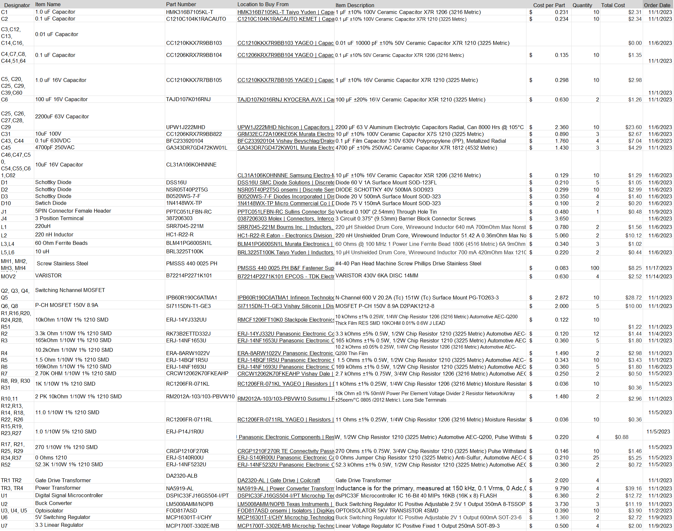

*Table 1 Power Inverter Prototype Bill of Material*

SOLAR LIGHT SYSTEM

Jeb Malek

**Power Converter Subsystem Report**

REVISION – Final

3 December 2023

1. **Converter Introduction**
   1. ***Scope***

This subsystem entails the hardware and software design, PCB manufacturing, and assembly for the power converter of the solar light system.

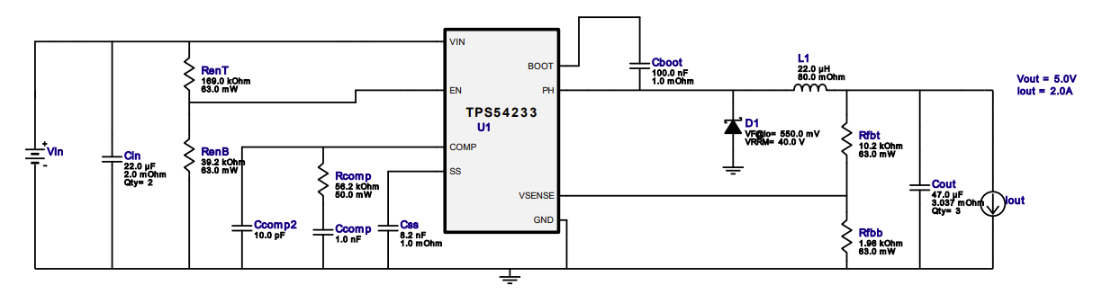

*Figure 12 Power Converter Circuit*

* 1. ***Buck Converter***
     1. **PWM Duty Cycle Signal**

In order to create a DC battery to DC load voltage converter from a higher 12 volt level to a smaller regulated steady state output with a constant value of close to 5V nominal.

A 12V input is designed for and will be sourced from a DC battery bank. In order to complete conversion of voltage a PWM Duty Cycle is required.

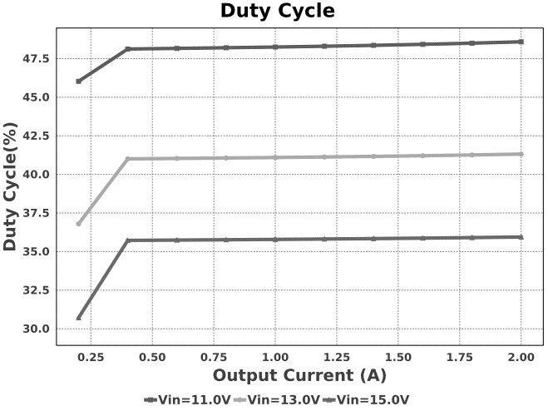

1. **Converter Details**
   1. ***Battery Source***

Supplying a DC voltage source will be done with a 12 V Lead Acid Battery Pack will provided the necessary voltage to convert to the 5 V nominal values that were needed for load testing.

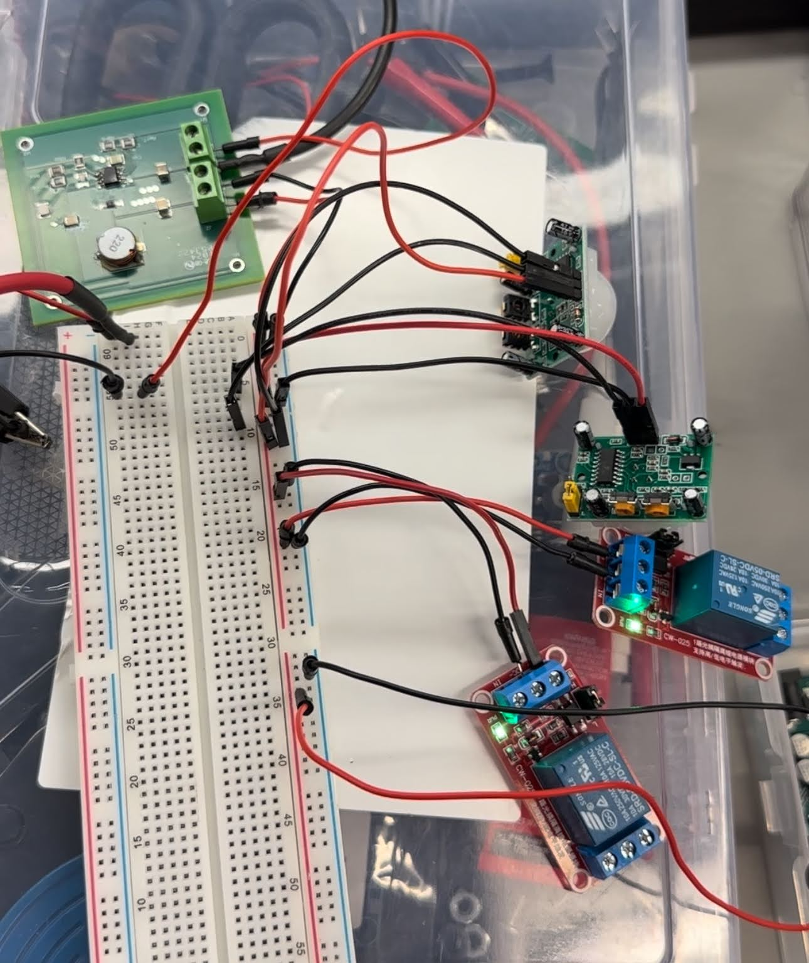

*Figure 14 5V Power Supply Regulation*

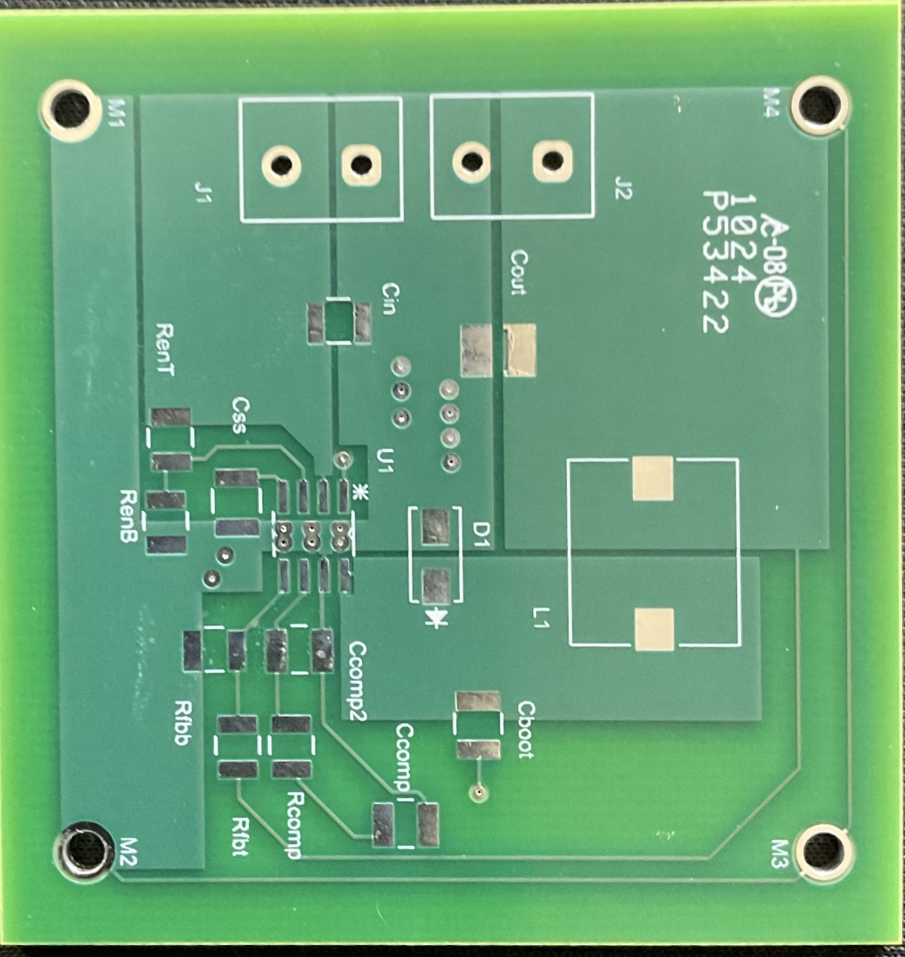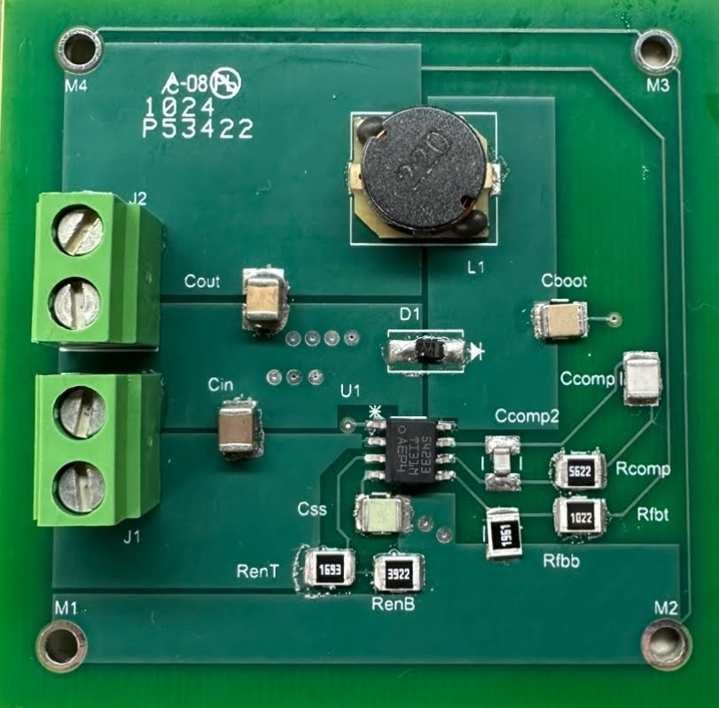

*Figure 15. Printed 5V Converter*

To properly power a buck voltage converter is used for low current DC/DC conversion.

1. **Converter Validation**

Converter validation was achieved with full system load testing.

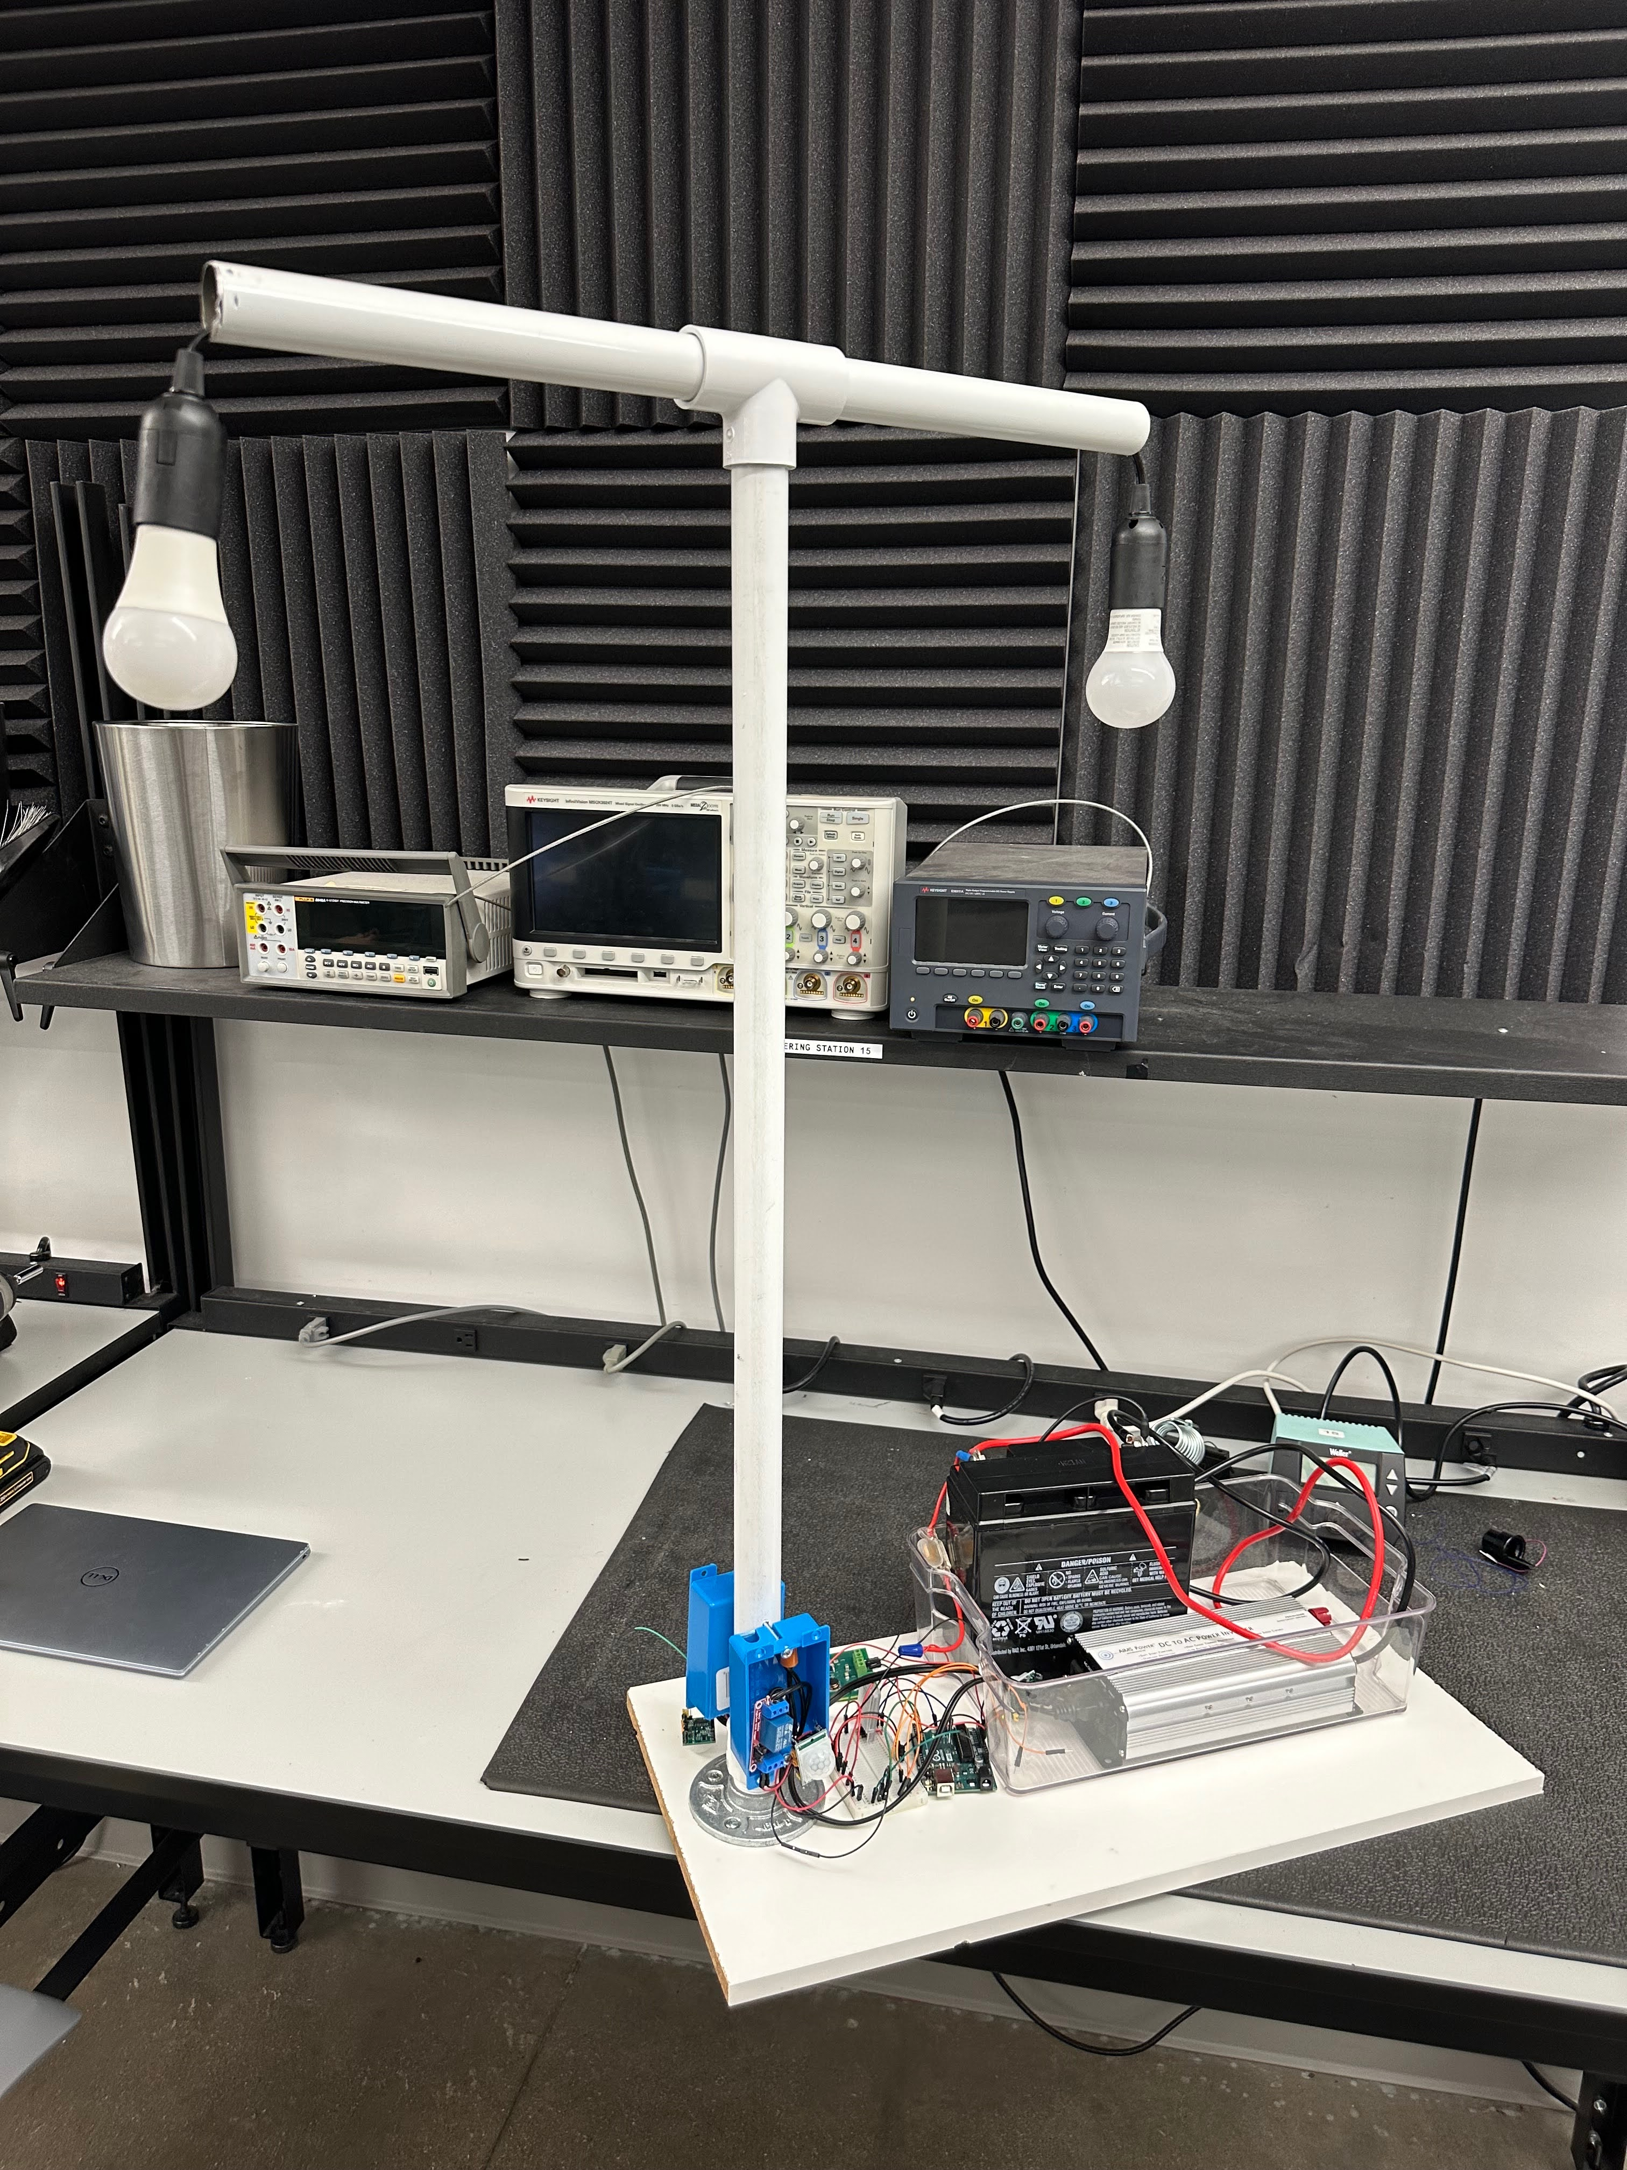

Figure 16*. Converter Validation*

1. **Converter Conclusion**

Rated for 200VA , this inverter will be able to supply a large portion of a typical residential housing load, as there can will be a normal operating load around 45W with the minimum of 3 15 W LED Lights installed during the integration of subsystems.

In looking forward to the next 6 weeks of the execution plan a prototype board shipment will arrive , with three boards to perform testing on. Soldering procedures of small package components progressing to larger sizes will ease the assembly process and a cascaded validation plan will be implemented to verify each stage of this power inversion process. In reflection of this project’s initial stage of validation important decisions to fit a board size constraint of 30 square inches required unanticipated delay in board ordering schedule. Along with verification of design rule checks without any errors contributed to further delay in schedule. Progress towards prototype completion and consideration of thermal and efficiency improvements will be of focus upon subsystem validation.

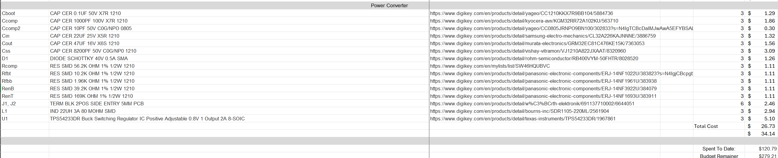

*Table 1 Power Converter Bill of Material*